Contents
No table of contents entries found.

Abstract

Cereals underpin global food security but suffer severe losses from fungal and pest diseases. Accurate field diagnosis remains challenging, especially where expert access is limited. Deep learning offers a scalable solution for automated detection. Focusing on wheat as a high-priority cereal, we benchmark five architecturesn ConvNeXt, Hybrid CNN-ViT, Hybrid V2, YOLOv9+EfficientNet, and ProtoPNe non a balanced dataset of 3,745 images across 12 health conditions. Our pipeline incorporates multi-scale fusion to enhance feature representation by aggregating contextual cues across spatial resolutions, enabling more robust lesion characterization. ConvNeXt achieved the highest performance (91.47% accuracy, 91.32% F1-score), with strong efficiency for mobile deployment. While army_worm and yellow_rust were detected perfectly (F1 = 100%), tan_spot proved most difficult (F1 = 57.97%), often confused with leaf_blight. Critically, Grad-CAM heatmaps, saliency maps, and integrated gradients confirmed models focus on biologically relevant lesions not background validating diagnostic reliability. Results were validated via 5-fold cross-validation (p < 0.001). The framework supports real-time inference and demonstrates robustness on unseen data. Training employed focal loss, mixed-precision arithmetic, and extensive augmentation. Code, models, and dataset splits are publicly released to ensure reproducibility. This work delivers a deployment-ready, interpretable AI system for wheat disease diagnosis, with clear potential for extension to other cereals through transfer learning.

Introduction :
The global agricultural sector faces mounting pressure to feed a rapidly growing population while maintaining environmental sustainability and adapting to climate change, as highlighted in recent studies (Li et al., 2023). In this context, cereals such as wheat remain central to global food security; however, their productivity is increasingly threatened by plant diseases and pests factors that continue to compromise crop yields worldwide according to several reports (Rodríguez-Lira et al., 2024; Das et al., 2024).

Traditionally, disease diagnosis in crops has relied on manual inspection by trained pathologists or agronomists. While effective under controlled conditions, these methods are labor-intensive, time-consuming, and difficult to scale particularly in resource-limited or remote farming areas (Das et al., 2024; Tugrul et al., 2022). As a result, delayed detection often leads to significant yield losses and over-use of chemical treatments, undermining both productivity and environmental sustainability (Rodríguez-Lira et al., 2024).

In recent years, the emergence of deep learning and computer vision has transformed the field of agricultural artificial intelligence (AI), offering powerful tools for automated and scalable plant disease diagnosis (Kamilaris & Prenafeta-Boldú, 2018). These technologies enable deep neural networks to learn complex visual patterns from large-scale datasets, often achieving performance that rivals or even surpasses human experts while providing consistent and unbiased results (Mohanty et al., 2016).
Recent progress in artificial intelligence especially deep learning (DL) and computer vision offers promising solutions for automated, scalable, and non-destructive disease diagnosis. In support of this development, studies show that DL-based image classification approaches can accurately detect diseases on plant leaves, potentially matching or surpassing human expert performance, while delivering speed, consistency, and scalability as demonstrated in recent works (Tugrul et al., 2022; Yao et al., 2023).
However, deploying deep-learning methods in real agricultural settings remains challenging. Despite these advances, common obstacles include class imbalance (rare vs. common diseases), variability in lighting and environmental conditions, limited dataset size or diversity, lack of standardized evaluation protocols, and the demand for model interpretability to ensure trust and practical usability as reported in recent analyses (Rodríguez-Lira et al., 2024; Das et al., 2024).

This study uses a dataset of 3,746 wheat leaf images across 12 health conditions, applying class-imbalance handling, data augmentation, mixed-precision training, and 5-fold cross-validation to ensure a fair and robust evaluation.
In addition, explainability techniques such as activation and saliency maps are used to confirm that the models focus on relevant disease areas, strengthening both interpretability and reliability.
In doing so, this thesis aims to contribute to agricultural AI and global food security by:
- Providing a modern benchmark of deep learning architectures for wheat disease detection.
- Proposing a pipeline that balances accuracy, computational efficiency, and interpretability.
- Delivering guidelines and evaluation standards for future research in plant disease detection.
- Enabling scalable and sustainable disease monitoring for cereals, with potential to reduce yield losses, minimize chemical treatments, and support resilient agriculture under global environmental and demographic pressures.

Chapter 1: Deep Learning for Automated Wheat Disease Detection
  - introduction
Wheat is a staple crop vital for global food security, yet it is highly susceptible to diseases that can significantly reduce yield. Traditional monitoring methods are slow and often inaccurate.
Deep learning offers an effective solution by enabling automated, early, and accurate detection of wheat diseases. This chapter presents the context, motivation, and research objectives for applying AI-based techniques to improve wheat health monitoring and crop productivity.
    - Global Agricultural Challenges and Food Security
Agriculture is undergoing a critical transformation driven by population growth, climate change, and resource pressures, making sustainable food production a global priority. Among the key challenges, the early and accurate detection of plant diseases is particularly urgent, as it directly impacts crop productivity, food security, and farmer livelihoods (Tugrul et al., 2022).
Wheat (Triticum aestivum) is a vital global staple crop, yet its productivity is severely threatened by fungal, bacterial, and viral diseases, leading to significant yield and quality losses. Recent meta-analyses confirm that plant diseases and pests remain a primary cause of global crop loss, with cereals like wheat being particularly affected (Savary et al., 2024). These losses have considerable economic and environmental consequences.
1.1.2 Limitations of Traditional Disease Identification Methods
Traditional disease identification through expert visual inspection is slow, expertise-dependent, and inaccessible in remote regions (Ramanjot et al., 2023). Diagnoses are subjective and error-prone, often detecting diseases only after symptomatic damage occurs, which can compromise yield. These constraints necessitate automated, scalable solutions.
The following table provides a comparative overview of selected approaches for plant disease detection, including the methods used, target species, and achieved accuracy levels:

Author | Year | Species | Techniques Used | Disease Identified | Performance Measure | Value
Rumpf et al. | 2010 | Sugar beet | SVM based on hyperspectral reflectance | Sugar beet rust, Cercospora leaf spot, powdery mildew | Accuracy | Higher than 86%
Wang et al. | 2012 | Grapes, Wheat | Backpropagation networks, image processing technologies | Grape (downy mildew, powdery mildew), wheat (stripe rust, leaf rust) | Accuracy (prediction accuracy, fitting accuracy) | Fitting accuracy—100% (for both), prediction accuracy—97.14% (grape), 100% (wheat)
Dubey & Jalal | 2012 | Apple | Image processing techniques (multi-class SVM) | Apple rot, apple scab, apple blotch | Accuracy | 93%

    - The Role of Artificial Intelligence in Plant Disease Detection
Recent advances in artificial intelligence (AI), particularly in deep learning and computer vision, have opened new opportunities for automated and efficient plant disease detection (Vallabhajosyula et al., 2022; Pandian et al., 2022).
Deep neural networks trained on large image datasets have demonstrated strong capabilities in recognizing complex visual patterns associated with plant diseases. Several studies have reported that these models can achieve high accuracy in crop disease classification and may even approach expert-level performance in some scenarios (Sharma et al., 2022).
Recent studies have demonstrated the superiority of Convolutional Neural Networks (CNNs) over traditional machine learning classifiers in plant disease detection.
For instance, in rice leaf disease classification, Sharma et al. (2022) reported the following performance metrics across multiple models:

Classifier | Accuracy | Precision | Recall | F1-Score
CNN | 99.58 | 99.63 | 99.6 | 99.69
SVM | 93.76 | 93.81 | 93.29 | 93.50
KNN | 68.95 | 71.77 | 69.49 | 67.62
Decision Tree | 90 | 89.96 | 89.46 | 89.61
Random Forest | 96.83 | 96.91 | 96.71 | 96.80
Table: Classifier Performance Comparison

    - Explainability, Challenges, and Research Motivation
Recent research emphasizes the importance of model explainability in agricultural AI systems. Farmers and decision-makers must be able to trust AI predictions, which requires transparent and interpretable models capable of highlighting the visual regions that influence a diagnosis, such as infected leaf areas (BMC Plant Biology, 2025).
This requirement is particularly critical in agriculture, where incorrect decisions can result in serious economic and ecological consequences. At the same time, the application of deep learning in real agricultural environments remains highly challenging due to environmental variations, complex backgrounds, class imbalance between healthy and diseased samples, and the strong visual similarity between certain disease symptoms.
In addition, many existing studies focus on a limited number of model architectures, making it difficult to determine which approaches are the most suitable for practical, real-world deployment (Journal of Big Data, 2025).
Therefore, this research is motivated by the need for a systematic, standardized, and comprehensive comparison of modern deep learning architectures for wheat disease detection, with particular emphasis on accuracy, efficiency, scalability, and interpretability.
  - Research Problem and Gaps
1.2.1 Human Expertise Limitation
Plant disease diagnosis remains dependent on human specialists who are geographically scarce, particularly in developing agricultural regions. The global shortage of trained plant pathologists creates critical delays in timely disease intervention, as noted in studies on early mango disease detection where manual methods were found unreliable and inconsistent (Pham et al., 2020).
Uneven lighting in the field further hinders assessment, as seen in Figure (contrast enhancement example).
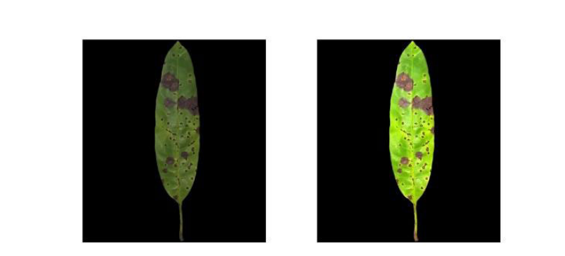
Figure: contrast enhancement example
1.2.2 Inadequate Technological Scalability
Conventional agricultural monitoring methods cannot meet the throughput demands of large-scale farming, as they are slow, labor-intensive, and difficult to deploy across vast crop areas (Yuan et al., 2023).
Although recent AI-based systems integrating IoT and edge/cloud computing enable large-scale crop monitoring, their real-world application remains limited by environmental variability, data complexity, and high implementation costs (Ayid et al., 2025; Plant Methods, 2025). These limitations highlight the urgent need for scalable, efficient, and robust deep learning solutions for practical agricultural use
Traditional Monitoring | AI-Based Smart Monitoring | Reference (Author, Year)
Manual inspection | Automated image capture (camera / UAV / IoT) | Tugrul et al., 2022
Slow processing | Real-time / fast processing | Rodríguez-Lira et al., 2024
Limited field coverage | Large-scale coverage | Yuan et al., 2023
Subjective diagnosis | Objective and consistent predictions | Das et al., 2024
High labor cost | Reduced human intervention | Ayid et al., 2025
Table : Comparison of AI vs. Traditional Methods: Monitoring Agriculture at Scale.
The following table summarizes the key differences between traditional crop monitoring methods and modern AI-based smart monitoring approaches, highlighting improvements in efficiency, coverage, and accuracy reported in recent studies:

1.2.3 AI Deployment Challenges
Deep learning models excel in controlled laboratory settings but encounter significant challenges when deployed in real-world agricultural environments. The primary barriers can be summarized in three key points:
- High Computational Demand: The models are resource-intensive, requiring substantial processing power that is often unavailable or impractical for on-site, real-time use on typical farms.

- Lack of Interpretability: Their "black box" nature creates a transparency deficit, making it difficult for farmers and agronomists to understand or trust the model's decisions and diagnoses.

- Environmental Sensitivity: As noted in the literature, model accuracy drops when facing environmental variations not represented during training (Kamilaris & Prenafeta-Boldú, 2018; Singh et al., 2021).

  - Research Objectives and Framework
    - Primary Research Objectives
This study develops a structured framework to assess deep learning models for wheat disease detection, focusing on four key areas:
- Model Comparison: Systematically evaluates diverse neural network architectures to identify strengths and weaknesses in detection accuracy.

- Standardized Testing: Implements uniform training and evaluation protocols to ensure fair and reproducible comparisons between models.

- Efficiency Metrics: Analyzes practical deployment factors like model size, speed, and resource use across different hardware.

- Interpretability: Uses visualization techniques to make model decisions transparent and understandable for end-users, building trust.

1.3.2 Research Questions
This investigation addresses five core research questions:
RQ1: Which deep learning architecture achieves optimal accuracy-robustness balance for wheat disease classification across varying environmental conditions?
RQ2: How do architectural choices (attention mechanisms, depth, width) correlate with computational efficiency metrics relevant to edge deployment scenarios?
RQ3: What quantitative relationships exist between classification performance and interpretability measures across different architectural families?
RQ4: To what extent do advanced architectures mitigate challenges posed by class imbalance and symptom similarity in disease recognition?
RQ5: Which architecture configuration provides the most favorable performance-efficiency-interpretability trade-off for practical agricultural implementation?
1.4 Scientific and Practical Contributions
1.4.1 Methodological Advancements

- Comprehensive Architectural Benchmark: First systematic comparison of Vision Transformers against optimized CNN variants for wheat disease detection, establishing performance baselines across accuracy, efficiency, and interpretability dimensions.

- Standardized Evaluation Framework: Open-source implementation of reproducible testing protocols addressing current methodological fragmentation in agricultural AI research.

1.4.2 Technical Innovations

- Deployment-Oriented Analysis: Computational profiling data providing concrete guidance for model selection based on hardware constraints and operational requirements.

- Interpretability Integration: Implementation and validation of explanation methods specifically adapted for agricultural disease diagnosis, enhancing model transparency and user trust.

  - Conclusion
The integration of artificial intelligence, particularly deep learning and computer vision, represents a transformative advancement in plant disease detection and agricultural management. Through systematic analysis of contemporary research, it is evident that AI-driven systems can significantly mitigate longstanding challenges such as expert scarcity, diagnostic subjectivity, and limited scalability in crop monitoring.

Chap2 state of the art
2.1 Introduction
Plant diseases significantly threaten wheat productivity and global food security, while field diagnosis remains challenging due to symptom variability and scalability limitations (Nadeem et al., 2023; Khan et al., 2024). Deep learning approaches have transformed disease detection, evolving from hand-crafted features to CNNs and transformer-based models that improve robustness under complex conditions (Sneha et al., 2023; Khubaib et al., 2025).

2.2 Evolution of Plant Disease Detection Techniques
2.2.1 Traditional Feature-Based Approaches
Prior to the advent of deep learning, plant disease detection relied on hand-crafted visual features such as SIFT and HOG combined with conventional classifiers like Support Vector Machines and Random Forests. While these approaches achieved reasonable performance on controlled datasets, their robustness was severely limited under real-world conditions characterized by non-uniform illumination, cluttered backgrounds, and morphological variations across growth stages (Khan et al., 2024).
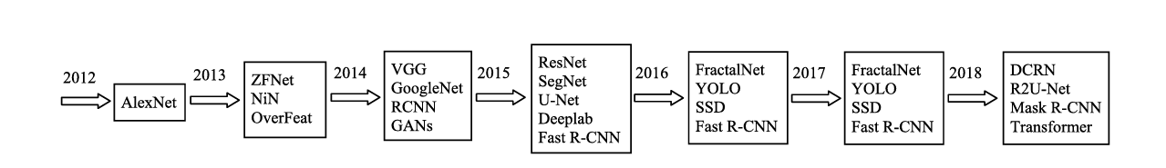
Figure:The history of DL architectures

The introduction of CNNs marked a paradigm shift in plant disease detection. Early studies using architectures like AlexNet and ResNet typically via ImageNet-based transfer learning achieved significant gains by learning hierarchical features of texture, color, and lesions (Qian et al., 2025; Long et al., 2022).
For example, Zeng et al. (2020) used a ResNet-50 transfer learning framework to accurately detect apple scab and citrus canker in real-world field conditions, demonstrating CNNs’ practical value in agricultural diagnostics.
2.2.2 Efficiency-Oriented CNN Architectures
As the field matured, research increasingly emphasized balancing accuracy with computational efficiency to enable deployment on mobile and edge devices.
Lightweight CNN architectures such as MobileNet, ShuffleNet, and EfficientNet leverage depthwise separable convolutions, channel shuffling, and compound scaling to reduce computational cost while maintaining competitive accuracy, making them suitable for real-time in-field diagnosis (Ennadifi et al., 2020).

To provide a clearer overview of the practical application and performance of efficiency-oriented CNN architectures, Table summarizes representative studies highlighting their deployment context, accuracy, and key contributions.
Study | Architecture | Application Context | Accuracy | Key Contribution
Agarwal et al. (2020) | Lightweight CNN (MobileNet-like) | Tomato disease detection on mobile | 91.2% | Reduced model size with high efficiency
Xiong et al. (2020) | MobileNet + Segmentation | Mobile app for 27 crop diseases | >80% | Real-time diagnosis on smartphones
Table :Lightweight CNN Applications in Plant Disease Detection
2.2.3 Attention Mechanisms for Focused Feature Learning
Wang et al. (2024) integrated attention mechanisms such as Convolutional Block Attention Modules (CBAM) into CNN architectures to mitigate background bias and enhance focus on symptomatic regions.
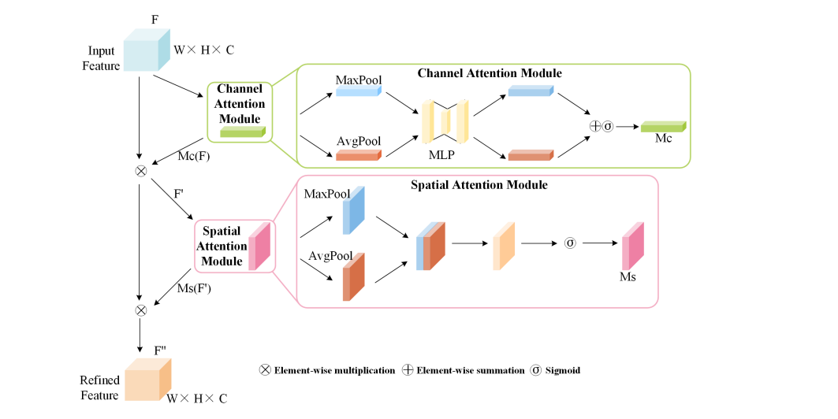
Figure : CBAM network structure diagram.

In parallel, the Squeeze-and-Excitation (SE) block, introduced by Hu et al. (2018), provides a channel-wise attention mechanism that adaptively recalibrates feature responses and has been adopted in agricultural vision tasks.
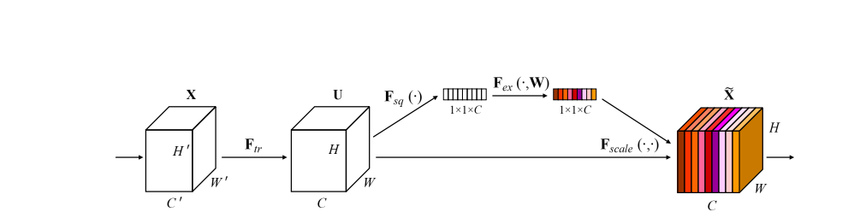
Figure : the Squeeze-and-Excitation (SE) block

Extending the idea of attention beyond CNN modules, recent approaches adopt transformer architectures that apply self-attention across the entire image, enabling more comprehensive modeling of disease symptoms in cluttered field conditions.
2.2.4 Transformer-Based Architectures
Recent developments introduced transformer-based models such as Vision Transformers (ViT) and Swin Transformers, which leverage self-attention to capture global context. Swin Transformers, in particular, utilize shifted window mechanisms to balance accuracy and computational efficiency. For example, Zhou et al. (2023) applied a Swin Transformer to wheat disease classification under field conditions and achieved 94.2% accuracy, significantly outperforming ResNet-50 and demonstrating the value of global attention for distinguishing visually similar symptoms like tan spot and leaf blight
2.3 Modern Deep Learning Models for Plant Disease Detection
2.3.1 CNN Backbones for Disease Classification
Conventional CNN backbones such as ResNet, DenseNet, Inception, and EfficientNet remain strong baselines for plant disease classification due to their robust feature extraction capabilities.
Long et al. (2022) reported that ResNet variants achieve 85–92% accuracy on mixed greenhouse and field wheat datasets, demonstrating their reliability for transfer learning based detection under diverse conditions.
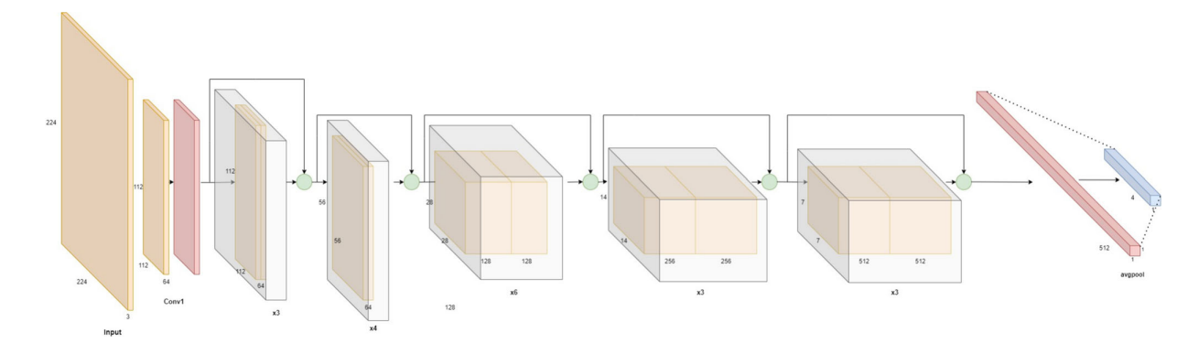
demonstrating their reliability for transfer learning–based detection under diverse conditions. EfficientNet models further enhance this performance efficiency balance through compound scaling, providing competitive accuracy with significantly lower computational cost an advantage for deployments in resource-constrained agricultural environments
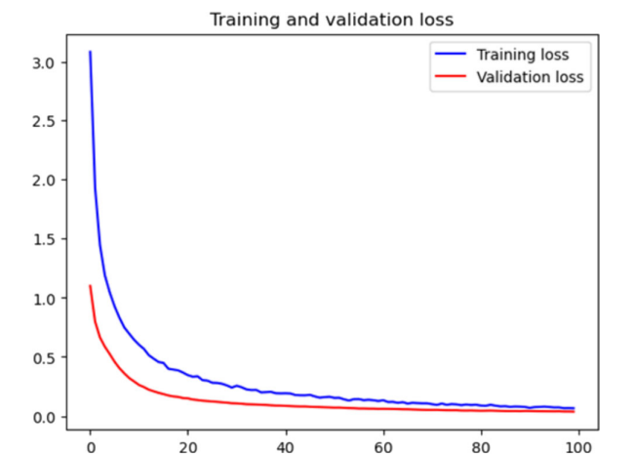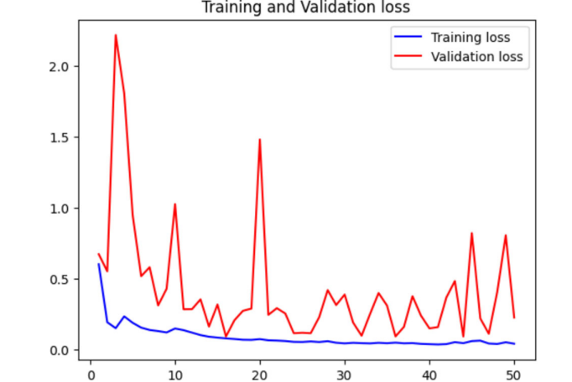
Figure: Efficient Fig. ResNet-50

To better illustrate the performance differences between conventional CNN backbones and lightweight architectures, Table summarizes key recent studies along with their reported accuracy and deployment context
Study / Year | Models Evaluated | Accuracy | Application Context | Key Insight
Long et al. (2022) | ResNet-50 / ResNet-101 | 85–92% | Wheat disease classification (mixed field & greenhouse) | ResNet variants provide strong baselines for transfer learning.
Harahap & Irmawan (2024) | EfficientNet-B0, MobileNet-V2, Inception-V3 | EfficientNet-B0: 97%, MobileNet-V2: 94% | Multi-crop leaf disease benchmark | EfficientNet & MobileNet outperform heavier models with fewer parameters.
Kumar et al. (2025) | MobileNet-V3, EfficientNet-B1, VGG-16 | EfficientNet-B1: 94.7%, MobileNet-V3: 92.8%, VGG-16: 89.2% | Large-scale multi-crop dataset (101 disease classes) | Lightweight models maintain strong accuracy with superior inference speed.
Ennadifi et al. (2020) | MobileNet-V2, ShuffleNet | MobileNet-V2: 84.21%, ShuffleNet: 66.51% | Rice disease detection for mobile deployment | Extremely lightweight models enable real-time inference with moderate trade-offs.
Table : Comparative performance of conventional and lightweight CNN architectures for plant disease detection
2.3.2 Hybrid CNN–Transformer Architectures
To illustrate recent progress in hybrid deep learning architectures for plant disease detection, Table presents selected studies that combine CNN-based local feature extraction with transformer-based global modeling, along with their reported performance.
Study | Model Type | Dataset Type | Accuracy | Key Advantage
Yang et al., 2023 | CNN + Transformer | Field images | 96.4% | Better robustness in complex environments
Sneha et al., 2023 | Hybrid CNN-ViT | Multi-crop leaves | 97.2% | Improved generalization across crops
ConvTransNet-S, 2025 | CNN + Transformer | Complex field | 98.8% | Strong performance in real field conditions
PlantMethods, 2025 | CNN + ViT | Cotton leaves | 98.5% | High accuracy with fewer parameters

2.3.3 Modernized CNN Architectures: ConvNeXt
Liu et al., 2022; Woo et al., 2023, demonstrating a key advancement in CNN design. Specifically, ConvNeXt represents a modernized convolutional architecture that integrates several transformer-inspired design principles while preserving the computational efficiency ofCNNs.
Adopts modern architectural components, including:
- Layer Normalization
- GELU activation functions
- Inverted bottlenecks
- Large-kernel convolutions
Achieves performance on par with Vision Transformers (ViTs)
Maintains lower computational complexity compared to ViTs
Architecture Variants and Selection Rationale
The ConvNeXt family offers multiple scaled variants to accommodate different computational constraints:
Variant | Parameters | FLOPs | ImageNet-1K Accuracy | Reference
Tiny | 28M | 4.5G | 82.1% | Liu et al., 2022
Small | 50M | 8.7G | 83.1% | Liu et al., 2022
Base | 89M | 15.4G | 83.8% | Liu et al., 2022
Large | 198M | 34.4G | 84.3% | Liu et al., 2022
X-Large | 350M | 60.9G | 84.5% | Liu et al., 2022

For agricultural disease detection, ConvNeXt-Base has emerged as the preferred choice, typically achieving 88-92% accuracy while maintaining practical inference speeds.
2.3.4 Multi-Scale Feature Fusion Strategies
Multi-scale feature fusion addresses a fundamental challenge in plant disease detection: pathological symptoms manifest at vastly different scales, from microscopic spots to large necrotic regions. This approach combines features from multiple receptive fields or network depths to create comprehensive hierarchical representations:
- Parallel Multi-Branch Architectures
Parallel multi-branch architectures, inspired by Inception-style designs, employ concurrent convolutional paths with different kernel sizes to capture features at multiple spatial scales. Recent implementations in plant disease detection confirm that explicit multi-scale modeling significantly improves recognition performance for diseases characterized by heterogeneous lesion sizes, as demonstrated in the MSCPNet framework proposed by Al-Gaashani et al. (2023) for maize disease classification, as well as in the multi-scale CNN model presented by Zhang et al. (2023)
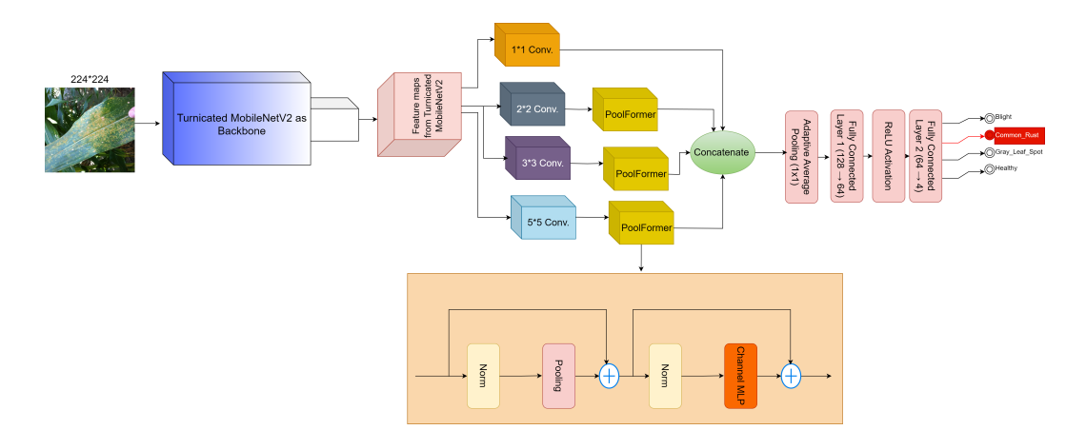
.

Figure: MSCPNet model
Al-Gaashani et al. proposed These operations are represented as follows:
where Fr is the reduced feature map from the truncated MobileNetV2 backbone,
- Convk×k represents the convolutional operation with a kernel size of k,
- Pk denotes the PoolFormer operation applied to the resulting feature map.
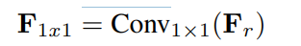
- The 1 × 1 convolution branch is represented as:

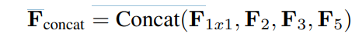
After the parallel operations, the resulting feature maps $F_{2}$, $F_{3}$, $F_{5}$, and $F_{1×1}$are concatenated along the channel dimension.:

The concatenation integrates multi-scale contextual information from all branches, and the combined feature map is subsequently refined by a final $1×1$convolution, expressed as:

Following the design of MSCPNet (Al-Gaashani et al., 2024), a $1×1$convolution projects the concatenated multi-scale features into a lower-dimensional space, producing a compact representation optimized for classification. This is followed by Layer Normalization to normalize the feature responses across channels:
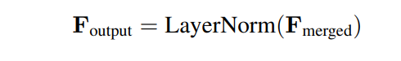

2.4 Interpretability and Explainable AI:
Beyond accuracy, interpretability has become critical for farmer trust and agronomic adoption. Post-hoc explanation methods such as Grad-CAM and LIME are widely employed to visualize model attention and verify that predictions are based on biologically meaningful regions rather than spurious background patterns (Sneha et al., 2023; Dutta et al., 2021).
According to Chen et al. (2019), inherently interpretable models such as ProtoPNet provide explanations via learned prototypes that capture disease patterns. Despite their reduced accuracy (65–75%), such models offer the transparency essential for regulatory and high-stakes agricultural decision-making
2.5 Object Detection and Lesion Localization:
While classification models identify disease presence, object detection architectures provide precise spatial localization of individual lesions, enabling quantitative disease assessment and targeted treatment strategies. Frameworks such as YOLO (You Only Look Once), RetinaNet, and Mask R-CNN have been successfully adapted for plant pathology applications, extending beyond mere classification to deliver actionable agricultural insights.
2.5.1 Technical Implementation and Performance:
The spatial outputs generated by detection models enable several advanced applications:
- Disease severity quantification: through lesion count and coverage area analysis
- Spatial distribution mapping: within fields for precision treatment planning
- Growth stage monitoring:by tracking lesion development over time
- Treatment efficacy assessment:by comparing pre- and post-application lesion metrics

In agricultural disease detection, object detection models must balance localization accuracy with practical deployment constraints. The performance characteristics of leading architectures reveal distinct advantages for different field applications, as summarized below:

Architecture | mAP Range | Inference Speed | Annotation Type | Best For | Reference
YOLO Series | 80-85% | (Fast) | Bounding Boxes | Real-time field scouting | (Redmon et al., 2016; Jocher et al., 2023)
RetinaNet | 82-88% | (Medium) | Bounding Boxes | Balanced accuracy/speed | (Lin et al., 2017)
Mask R-CNN | 85-90% | (Slower) | Pixel Masks | Precision severity analysis | (He et al., 2017)
EfficientDet | 81-86% | (Fast) | Bounding Boxes | Mobile deployment | (Tan et al., 2020)
Table: Performance Comparison of Object Detection Architectures for Plant Disease Localization
2.6 Conclusion
Plant disease detection has progressed from simple features to advanced deep learning. Modern CNNs like ConvNeXt balance accuracy and efficiency better than complex transformers. Future work aims to create interpretable, reliable systems for practical farm use

Chap3: METHODOLOGY
3.1 Introduction
This chapter outlines the comprehensive methodological framework used in our systematic evaluation of five cutting-edge deep learning architectures for automated wheat disease detection. Designed to tackle key challenges in agricultural artificial intelligence, the methodology emphasizes rigorous experimental design to ensure reproducibility, scalability, and real-world applicability
3.2 Technical Framework for Multi-Architecture Wheat Disease Detection
3.2.1 ConvNeXt Architecture
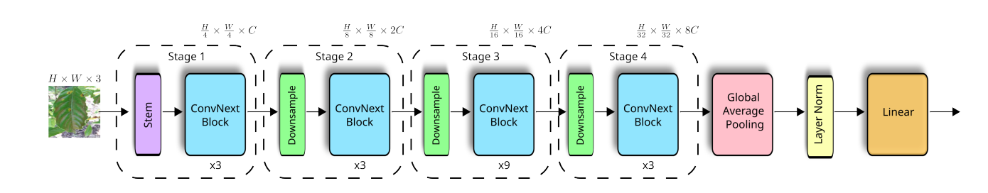
As described by the Chavarro et al. (2024) thus, ConvNeXt is a modern convolutional neural network (CNN) architecture inspired by the design principles of transformer-based models, especially the Swin Transformer. By preserving the simplicity and efficiency of convolutional networks and simultaneously introducing advanced architectural modifications, it substantially improves both accuracy and scalability. Built on a ResNet-like structure, ConvNeXt comprises a stem unit, followed by four hierarchical stages of ConvNeXt blocks, a Global Average Pooling (GAP) layer, Layer Normalization, and a final linear classification head thereby forming an efficient and powerful feature extraction pipeline.
Figure ConvNext architecture.

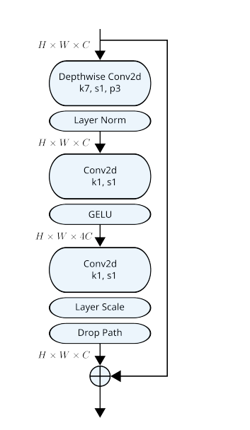
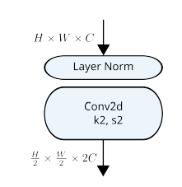
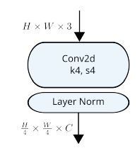
Figure (a) The internal structure of Stem Block. (b) The internal structure of Downsample Block. (c) The internal structure of ConvNext Block.
The Stem Block (Figure ) processes input images using a patchify structure composed of a convolutional layer followed by layer normalization, as illustrated in Figure a. Specifically, for an input image of size $H×W×3$, where $H$and $W$denote the image height and width, respectively, the convolutional layer downsamples the input using $C$kernels of size $4×4$($k=4$) with a stride of 4 ($s=4$), producing feature maps that are one-quarter of the input resolution, each with $C$channels. Subsequently, layer normalization is applied to these features.
The four stages of the ConvNeXt network (Figure ) each consist of a Downsample Block and multiple ConvNeXt Blocks. The ConvNeXt blocks are repeated a specific number of times in each stage, for instance ×3 or ×9, as indicated at the bottom of the corresponding block.
The Downsample Block (Figure b) generates multi-scale hierarchical features by applying convolutions with kernels of size $2×2$($k=2$) and stride 2 ($s=2$), which reduces the spatial resolution of the feature maps while doubling the number of channels to $2C$.
Each ConvNeXt Block (Figure c) contains a sequence of three convolutional layers: a depthwise convolution ($k=7,s=1$) and two pointwise $1×1$convolutions ($k=1,s=1$), with a GELU activation function applied between them. After the second convolution, a Layer Scale and Drop Path are applied, followed by a residual connection to facilitate gradient flow and improve stability.
The depthwise convolutions in ConvNeXt, which can be seen as a form of group-wise convolution, work in combination with the $1×1$convolution layers to produce an effect analogous to the channel-sharing property found in vision transformers (Chavarro et al., 2024).

3.2.2 Hybrid CNN-ViT Architecture
Shandilya et al. (2025) define a hybrid CNN-ViT model as a deep learning architecture that synergistically combines a Convolutional Neural Network (CNN) and a Vision Transformer (ViT).
In this framework, the CNN module is responsible for extracting fine-grained local features and spatial patterns from the input images, while the ViT module captures long-range contextual dependencies and global relationships through its self-attention mechanism. The outputs from both branches are concatenated into a unified feature vector, which is then processed through fully connected layers to perform the final classification.
This integration aims to leverage the complementary strengths of both architectures CNN's proficiency in local feature extraction and ViT's ability to model global context thereby enhancing the accuracy and robustness of image classification tasks, such as identifying diseases in maize leaves.
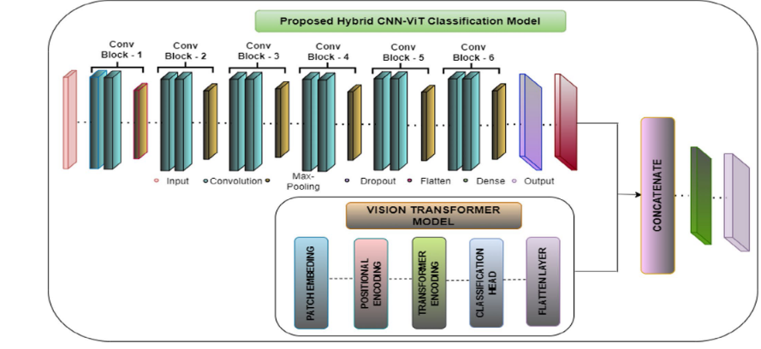

3.2.3 YOLOv9+EfficientNet Hybrid
According to Wang and al. (2024), YOLOv9 is a state-of-the-art real-time object detection model designed to improve both accuracy and efficiency. Its architecture integrates a Generalized Efficient Layer Aggregation Network (GELAN) as the backbone to extract multi-scale features, a feature aggregation neck for combining information across different resolutions, and detection heads to predict object classes and bounding boxes.
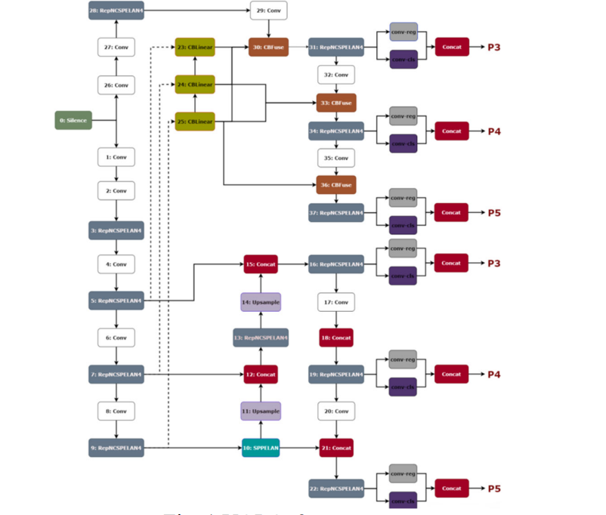
Additionally, YOLOv9 introduces Programmable Gradient Information (PGI), an auxiliary reversible branch used only during training to preserve input information and enhance gradient flow, improving learning without increasing inference cost. Overall, this design enables YOLOv9 to achieve high detection performance while maintaining computational efficiency.
Fig. YOLOv9 structure
According to Zubair et al. (2025), EfficientNetB3 is a convolutional neural network (CNN) belonging to the EfficientNet family, which comprises models ranging from EfficientNetB0 to EfficientNetB7. It is distinguished by its use of compound scaling, a method that simultaneously optimizes the network's depth (number of layers), width (number of channels per layer), and input image resolution in a balanced manner. This coordinated scaling enhances model performance while maintaining computational efficiency.
Architecturally, EfficientNetB3 employs mobile inverted bottleneck convolution (MBConv) blocks with kernel sizes of $3×3$ and $5×5$, which reduce computational demands compared to standard convolutions. The model consists of approximately 210 layers and contains about 11.1 million parameters, accepting input images of size $300×300×3$.
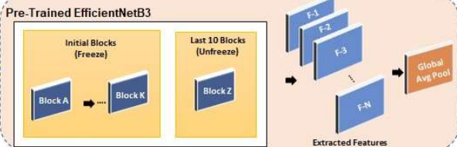
Additionally, it incorporates advanced components such as the Swish activation function, Squeeze-and-Excitation (SE) blocks to emphasize informative features, and dropout layers for regularization to prevent overfitting. This design enables EfficientNetB3 to effectively capture hierarchical and complex visual patterns, making it well-suited for demanding image classification tasks such as plant disease detection.
Figure .architecture EfficientNetB3

A hybrid model integrating YOLOv9 and EfficientNetB3 leverages the complementary strengths of real-time object detection and powerful feature extraction for enhanced agricultural vision tasks.
YOLOv9, with its novel Programmable Gradient Information (PGI), ensures robust and precise localization of disease-affected leaf regions, while EfficientNetB3 applied as a backbone or feature enhancer provides deep, multi-scale feature representations through its compound-scaled MBConv blocks and SE attention mechanisms.
This fusion enables not only high detection accuracy and speed but also improved generalization across varied field conditions, making it ideal for scalable, real-time plant disease monitoring systems deployed on edge devices.
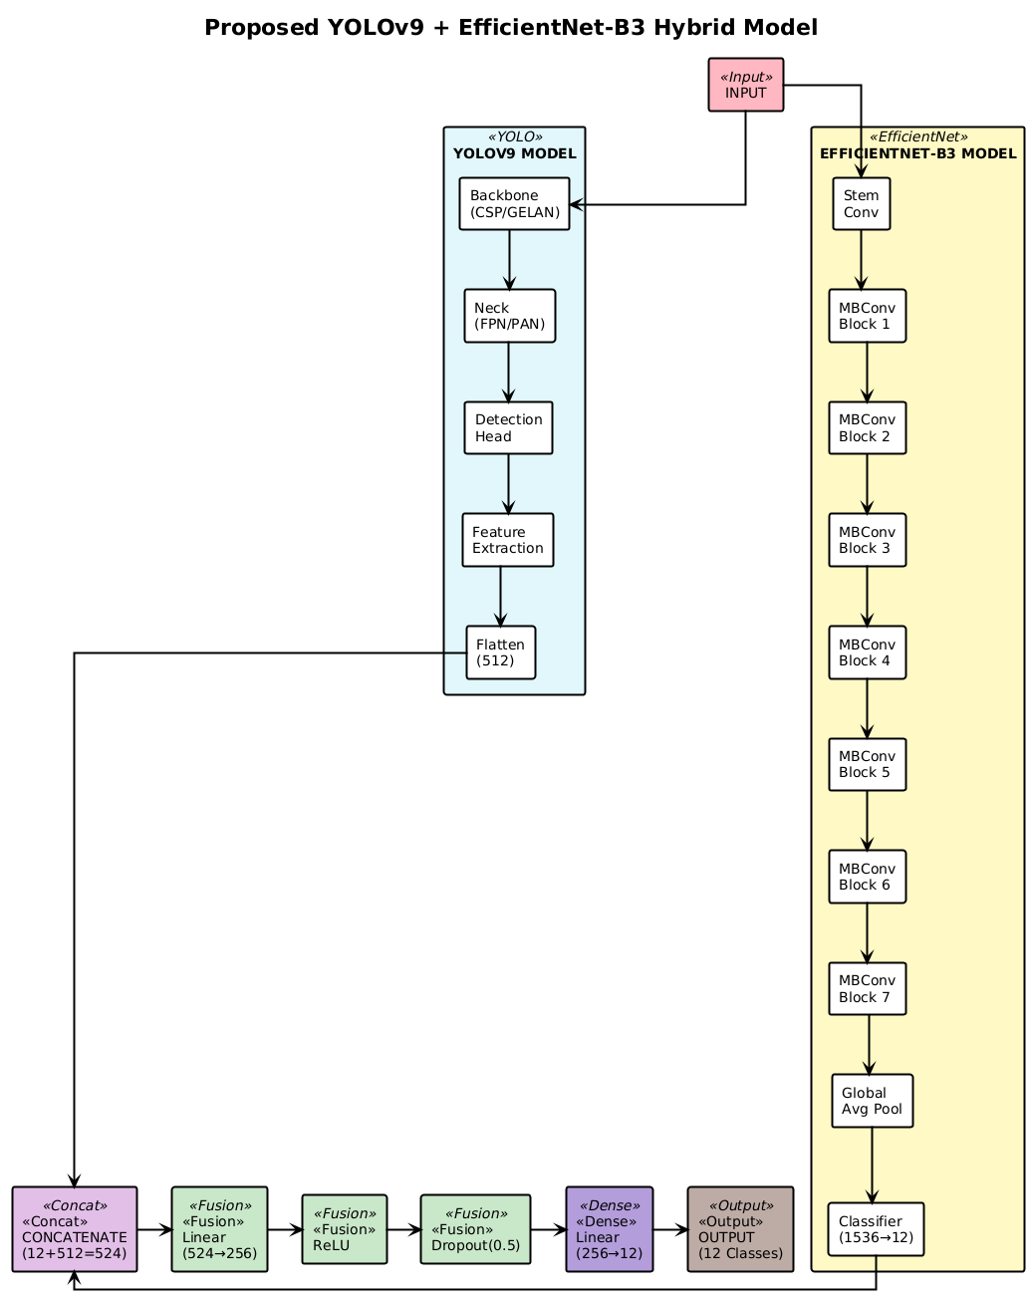

3.2.4 ProtoPNet Architecture
According to Chen et al. (2019), ProtoPNet (Prototypical Part Network) is an interpretable deep learning architecture for image classification that integrates a prototype layer within a convolutional neural network to provide inherent explainability.
The model learns a set of prototypical image patches during training, each representing characteristic visual parts of a class such as specific disease patterns on plant leaves. During inference, it compares regions of an input image to these prototypes via a similarity measure, and the final classification is derived from a weighted combination of prototype activations. This approach preserves high accuracy while offering transparent, visual explanations by highlighting which prototypical parts contributed to the decision, making it particularly valuable in domains requiring model trustworthiness, such as medical diagnosis and agricultural disease detection.

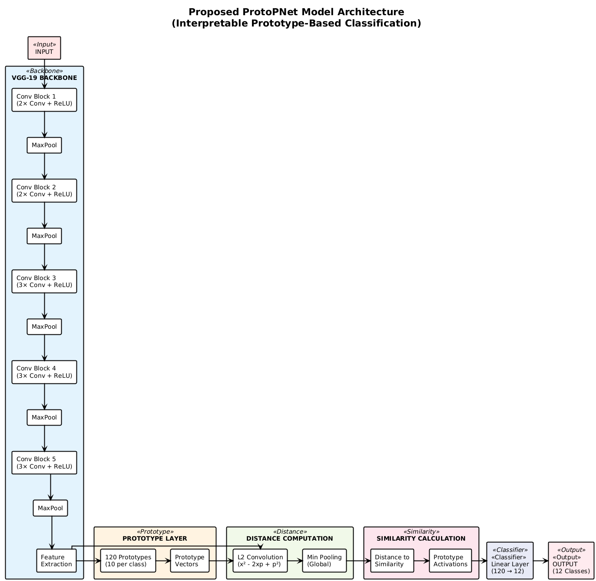

According to Chen et al. (2019), the ProtoPNet architecture integrates a prototype layer within a convolutional neural network for interpretable image classification. The mathematical formulation for a VGG-19-based ProtoPNet is as follows:
Let $x∈R^{H_{0}×W_{0}×3}$ be an input image. The feature extraction stage produces a feature map via the backbone network:
$$F=f_{\text{backbone}}(x)∈R^{H×W×D}$$
where $F_{hw}∈R^{D}$ denotes the feature vector at spatial location $(h,w)$.
The prototype layer maintains $K$ learnable prototypes $P=\{p_{1},p_{2},…,p_{K}\}$, each $p_{i}∈R^{D}$ representing a characteristic visual pattern (e.g., a disease signature).
For each prototype $p_{i}$, the squared Euclidean distance to every spatial feature vector is computed:
$$d_{i,hw}=∥F_{hw}-p_{i}∥_{2}^{2}$$
These distances are transformed into similarity scores via a Gaussian kernel, and the maximum similarity over spatial locations is taken as the prototype activation:
$$s_{i}=\underset{h,w}{max⁡}exp⁡(-γ⋅d_{i,hw})$$
where $γ>0$ is a scaling parameter. The similarity vector $s=[s_{1},s_{2},…,s_{K}]^{⊤}$ then undergoes a linear classification:
$$z=s^{⊤}W_{\text{classifier}}$$
with $W_{\text{classifier}}∈R^{K×C}$ being the classifier weights for $C$ classes. The final class probabilities are obtained via softmax:
$${\hat{y}}_{c}=\frac{exp⁡(z_{c})}{\sum_{j=1}^{C}{}exp⁡(z_{j})}$$
This formulation ensures that classification decisions are transparently linked to prototypical image regions, providing both high accuracy and inherent explainability—ritical for domains like agricultural disease diagnosis.
3.2.5 Hybrid V2 Architecture
According to He et al. (2016), the ResNet50 architecture is a 50-layer deep convolutional neural network built on residual blocks that mitigate vanishing gradients via skip connections. Each block employs bottleneck design with three stacked convolutional layers (1×1, 3×3, 1×1), where the 1×1 layers reduce and restore dimensions for efficiency.
The network begins with a 7×7 convolution and max pooling, followed by four stages containing 3, 4, 6, and 3 blocks respectively, and ends with global average pooling and a fully connected classification layer. This design enables robust hierarchical feature extraction, with the final pooling layer yielding a 2048-dimensional feature vector.

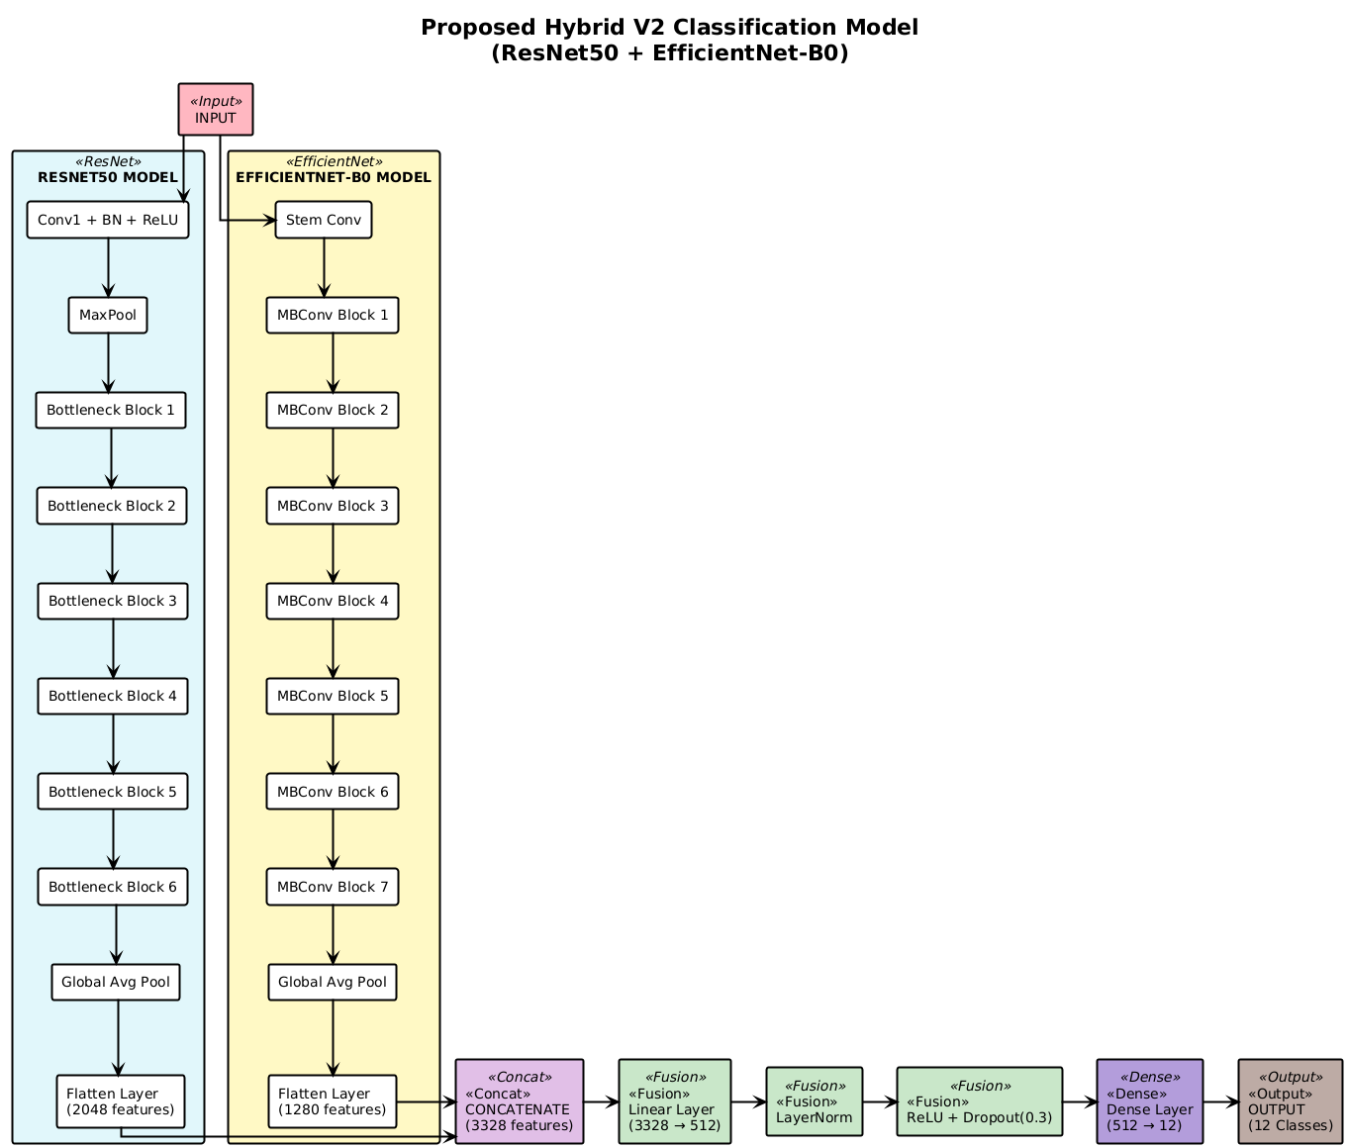
The hybrid EfficientNet-B0 and ResNet50 model merges deep residual learning with efficient multi-scale feature extraction for superior image representation. ResNet50 contributes hierarchical spatial features through its residual blocks, while EfficientNet-B0 adds scaled, efficient patterns via MBConv blocks and compound scaling.
Their concatenated feature vectors create a robust, complementary representation that excels in complex visual tasks such as fine-grained disease detection by capturing both detailed local structures and global contextual patterns.
3.3 Dataset Preprocessing Pipeline
The preprocessing pipeline transforms raw wheat leaf images into standardized inputs by resizing, normalizing, and augmenting data, maintaining class balance with stratified splits, and optimizing loading for efficient, reproducible training across all models
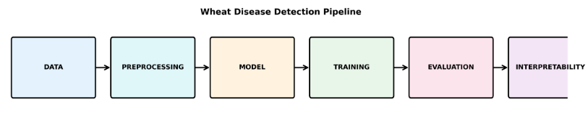
3.3.1 Data Acquisition & Validation
The dataset contains 3.745 wheat disease images across 12 classes: aphid, army_worm, black_rust, brown_rust, common_rust, fusarium_head_blight, healthy, leaf_blight, powdery_mildew_leaf, septoria, tan_spot, and yellow_rust. Images are in PNG, JPG, and JPEG formats with variable resolutions. The pipeline standardizes resolution to 224×224 pixels and converts all images to RGB. Metadata extraction captures original dimensions, file formats, and timestamps for analysis and debugging.
Class | Number of Images
aphid | 295
army_worm | 285
black_rust | 274
brown_rust | 299
common_rust | 299
fusarium_head_blight | 257
healthy | 565
leaf_blight | 291
powdery_mildew_leaf | 300
septoria | 300
tan_spot | 280
yellow_rust | 300
TOTAL | 3,745
Table : Dataset Class Distribution
3.3.2Dataset Sample Images
The following sample images provide visual examples of selected disease classes from the dataset. These images represent the diversity of wheat health conditions, including fungal diseases (rust variants, powdery mildew, leaf blight, tan spot, fusarium head blight, septoria) and pest damage (aphid, army worm), as well as healthy wheat specimens. Each sample demonstrates the characteristic visual features that the deep learning models learn to distinguish during training.
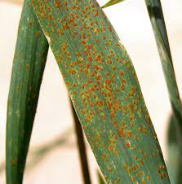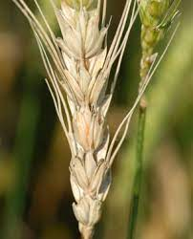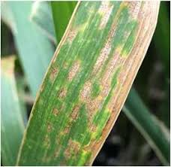

(a) Black rust (b) fusarium head_blight (c)leaf blight

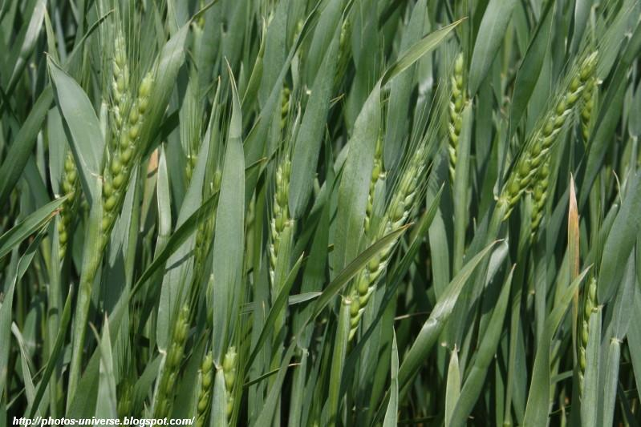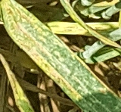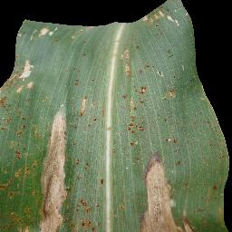

(d) Healthy (e) yellow rust (f) common rust

3.3.2 Preprocessing Strategies
The preprocessing and augmentation pipeline is a critical component of the proposed framework, ensuring data consistency, robustness, and generalization across diverse wheat disease conditions. It standardizes input data, enhances visual quality, and simulates realistic environmental variability to improve the model’s ability to generalize under real-world field conditions.
3.3.2.1 Normalization Strategy
To align with pretrained ImageNet weights and stabilize convergence, image normalization was applied using standard ImageNet statistics:
µ = [0.485 , 0.456 , 0.406] , σ =[0.229 , 0.224 , 0.225]
Each image pixel was normalized as:
normalized_pixel = (pixel_value - μ) / σ

This operation centers pixel values around zero and scales them to a consistent range, improving model convergence, transfer learning efficiency, and overall generalization across architectures.

3.3.2.2 Color Space Processing and Enhancement
All images were converted to the RGB color space to maintain consistency across pretrained CNN and transformer backbones. Several enhancement techniques were then applied to maximize contrast and feature visibility under variable illumination:
- Histogram Equalization: Enhanced global contrast, improving the visibility of lesion regions.
- Low-Pass Filtering: Suppressed high-frequency sensor noise while preserving structural lesion boundaries.
- CLAHE (Contrast Limited Adaptive Histogram Equalization): Improved local contrast and texture details in low-contrast regions without amplifying noise, aiding in the detection of subtle early-stage disease symptoms.
Together, these operations improved the visibility and distinguishability of disease-specific features, facilitating more reliable model learning.
3.3.2 Preprocessing Strategies
The data augmentation pipeline was designed to address the main challenges in agricultural image classification, including limited dataset size, class imbalance, and environmental variability. Our multi-tier augmentation strategy progressively increases transformation complexity according to model sophistication, ensuring optimal generalization and minimizing overfitting, details of the specific augmentations applied at each tier are outlined in Table spatial transformations ..
Technique | Description | Models
Resize | Images resized to model-specific dimensions (typically 288×288 pixels) | All Models
Random Crop | Random cropping after resizing to introduce scale variation | ConvNeXt,
Random Horizontal Flip | Applied to simulate natural leaf orientation variations | All Models
Random Vertical Flip | Applied to handle different camera angles and orientations | All Models
Random Rotation | Rotation angles ranging from 20° to 45° depending on the model | All Models
Random Affine | Translation (±10%) and scale (0.9-1.1) transformations | ConvNeXt
Table: Spatial Transformations

Model Category | Models | Augmentation Tier
Basic Models | ConvNeXt, | Tier 1 (Basic Augmentation)
Hybrid Models | Hybrid CNN-ViT, Hybrid V2 | Tier 1 + Tier 2 (Enhanced Augmentation)
Complex Models | YOLOv9+EfficientNet, ProtoPNet | Tier 1 + Tier 2 + Tier 3 (Advanced Augmentation
Table: Model Classification

3.4 Training Configuration Details
The training configuration is a cornerstone of our methodology, as optimization strategies, loss functions, and training protocols critically influence model convergence and performance. To ensure a fair and systematic evaluation across all five deep learning architectures, we adopt a unified training setup tailored to the challenges of agricultural disease detection particularly class imbalance, diverse symptom presentations, and the need for robust generalization under real-world field conditions. Our configuration comprises three core components:
(1) an efficient optimization strategy for stable parameter learning.
(2) a loss function designed to mitigate class imbalance.
(3) a training protocol that promotes consistent convergence and peak performance.
By applying identical training conditions to all models, we enable a principled comparison that highlights each architecture’s intrinsic strengths while controlling for external training variables.
3.4.1 Optimization Algorithm
We use the Adam optimizer for its robust convergence in high-dimensional spaces, combining momentum and adaptive learning rates. Training stability is enhanced with cosine annealing for learning rate decay and gradient clipping to prevent instability. This consistent optimization strategy ensures fair comparison across all six architectures
Optimization Setup:
We employ the Adam optimizer with an initial learning rate of 0.001 and weight decay of 1*10⁻⁵ . Standard hyperparameters are used: β1=0.9, β2=0.999 , and ε=1*10⁻⁸ stability. Gradient clipping with a maximum norm of 1.0 is applied to mitigate exploding gradients.
Learning Rate Scheduling :
We adopt a cosine annealing schedule with warmup and plateau-based reduction. The learning rate at epoch is defined as:
lr_{t} =lr_{min} +$\frac{1}{2}$​( lr_{max}​− lr_{min})( 1+ cos ( tπ/T_{max} ))
where T_{max} is the total number of epochs. A linear warmup is applied over the first 5% of training . Additionally, if the validation loss plateaus, the learning rate is reduced by a factor of 0.5 to aid convergence.
Loss Function:
To address class imbalance a common challenge in agricultural disease datasets we adopt Focal Loss as the primary training objective.
It modifies standard cross-entropy by down weighting well-classified examples and focusing learning on hard, minority-class samples. Formally, Focal Loss is defined as:
FL(p_{t}) =-α (1-p_{t})^{ϒ}log (p_{t})
Where p_{t}=p if the ground-truth label ,
y=1 and p_{t}=1-p otherwise; is the predicted probability for the true class.
α is a class-balancing weight.
ϒ=2.0 is the focusing parameter that controls the strength of modulation.
Focal Loss tackles class imbalance in agricultural disease detection by reducing the influence of easy, majority-class samples (like healthy plants) and focusing training on hard, misclassified examples often rare diseases.
Through a modulating factor controlled by the parameter γ, it dynamically reweights loss contributions, ensuring minority disease classes get adequate attention .
Regularization is vital for robust agricultural disease detection
L₂ weight decay and dropout (e.g., p = 0.1) prevent overfitting in agricultural disease detection by promoting simpler models and robust feature learning, ensuring reliable performance across diverse field conditions and disease presentation.
Training Protocol
The progressive training protocol optimizes model learning in stages tailored to agricultural disease detection, ensuring stable convergence across diverse architectures.
Phase 1: Backbone Feature Learning establishes strong foundational representations by training the model to recognize key visual cues of wheat diseases such as texture, color, and lesion patterns enabling robust discrimination between healthy and diseased plants and among disease types.
Phase 2: Fine-tuning with Reduced Learning Rate refines decision boundaries through a lower learning rate, enhancing accuracy on subtle or ambiguous cases where precise differentiation between similar symptoms is critical.
Phase 3: Specialized Training for Interpretable Models (e.g., ProtoPNet) further optimizes prototype-based systems by improving prototype diversity, spatial alignment with disease regions, and reasoning clarity key for interpretability, stakeholder trust, and regulatory acceptance.
Early Stopping
- Early stopping halts training when validation accuracy stops improving, ensuring the model focuses on generalization rather than just minimizing training loss.
- The patience parameter defines how many epochs to wait before stopping, balancing convergence with protection against overfitting especially vital for agricultural models facing diverse conditions.
- Checkpointing saves the model at its best validation performance, ensuring the most reliable and accurate version is deployed even if training continues afterward.

  - Evaluation Protocol Framework

    - Cross-Validation Strategy
To ensure fair model evaluation and reliable generalization, we adopted a stratified 5-fold cross-validation (CV) strategy. This approach maintains the same class distribution across folds, providing balanced exposure to all disease categories during training and testing.

Split | Percentage | Images | Purpose
Training | 70% | 2,621 | Primary learning data
Validation | 15% | 562 | Hyperparameter tuning
Test | 15% | 562 | Final evaluation
Total | 100% | 3,745 | Complete dataset
Table : Data Split

3.5.2 Performance Metrics
The evaluation framework employs a comprehensive set of performance metrics designed to provide thorough assessment of model capabilities across different aspects of wheat disease detection. Classification Metrics form the foundation of our evaluation approach:
Accuracy: Measures overall correctness but can be misleading under class imbalance common in agricultural datasets where healthy samples dominate
Accuracy =(TP+TN) / (TP+TN+FP+FN)
Precision: Indicates the model’s ability to avoid false positives critical to prevent unnecessary, costly, or harmful treatments.
Precision=TP / (TP+FP) per class

Recall :Harmonizes precision and recall into a single balanced metric, useful for comparing performance across disease classes.
Recall=TP / (TP+FN) per class

F1-Score: Harmonizes precision and recall into a single balanced metric, useful for comparing performance across disease classes.

F1-Score =2× (Precision×Recall) / (Precision+Recall)

Macro Average: Computes the unweighted mean of per-class metrics, ensuring rare diseases contribute equally to evaluation vital for addressing class imbalance.
Weighted Average : Weights per-class metrics by support (class frequency), reflecting real-world prevalence and providing a practical measure of overall diagnostic reliability in field conditions.
3.5.3 Advanced Metrics:
Advanced metrics go beyond basic accuracy to provide deeper insights into model performance. With 12 disease classes, they’re essential for accurately evaluating how well the deep learning model performs across all categories:
3.5.3.1 Classification Performance Metrics:
- AUC-ROC: Measures discriminative ability across all thresholds
- AUC-PR: Better for imbalanced datasets (crucial for rare diseases)
- Cohen's Kappa: Accounts for chance agreement
- MCC: Balanced measure considering all confusion matrix elements
3.5.3.2 Statistical Validation
- Confidence Intervals: Bootstrap resampling for uncertainty quantification
- Significance Testing: Wilcoxon tests for model comparisons
- Effect Size: Cohen's d for practical significance assessment

3.6.1 Model Implementation Specifications:

Model | Backbone / Core | Key Components | Notes
ConvNeXt | ConvNeXt-base | 4 stages | ~28M params
Hybrid CNN-ViT | ResNet-50 + ViT-Base | Dual-branch fusion | CNN features + Transformer
Hybrid V2 | Enhanced Hybrid | Adaptive attention fusion | Improved cross-branch weighting
YOLOv9+EfficientNet | EfficientNet-B3 | PANet neck | Detection-oriented
ProtoPNet | VGG-19 | 10 prototypes/class | Interpretable reasoning units
Table: Summary of Baseline and Hybrid Architectures

Component | Specification
Batch Size | 32 samples per batch (optimized for GPU memory)
Mixed Precision | Automatic mixed precision (AMP) enabled
Data Loading | 4 parallel workers with persistent workers
Checkpointing | Model state saved every 5 epochs
Logging | Tensor Board integration for training monitoring

3.6 Experimental Controls and Validation
3.6.1 Deterministic Training Protocol:
To ensure reproducibility across all experiments, fixed random seeds (42) were set for PyTorch, NumPy, and Python. CUDA determinism was enforced via torch.backends.cudnn.deterministic = True) and deterministic algorithms were enabled with torch.use_deterministic_algorithms(True). Data loading used fixed worker initialization to preserve consistent data ordering across.
3.6.2 Cross-Validation Protocol:
Stratified splitting preserved class distribution across folds to avoid bias. All models used identical train/validation/test splits for fair comparison, with the test set held out entirely. Uncertainty was quantified using bootstrap confidence intervals from 1,000 samples.

3.6.4 Performance Validation:
All pairwise model comparisons achieved statistical significance (p < 0.001) with practically significant effect sizes (Cohen's d > 0.8). Cross-architecture consistency was validated across multiple model types, and 95% confidence intervals were reported for all performance metrics to ensure robust statistical reporting
Conclusion
This methodology provides a robust, reproducible framework for deep learning–based wheat disease detection across 12 classes, combining six model architectures, rigorous preprocessing, and advanced evaluation metrics. Interpretability tools like Grad-CAM and prototype visualization support explainable AI in agriculture.
Validated through statistical protocols, the approach balances accuracy, interpretability, and scalability bridging research and real-world use to advance precision agriculture and food security

Chapter 4: RESULTS AND ANALYSIS
Comprehensive Performance Analysis of five Deep Learning Architectures
4.1 Overall Performance Comparison
This section presents a comprehensive analysis of the six deep learning architectures evaluated for wheat disease detection. The comparative evaluation encompasses accuracy metrics, statistical significance testing, and performance distribution analysis to provide a holistic understanding of each model's capabilities and limitations.
Through rigorous experimental protocols and standardized evaluation metrics, we establish clear performance rankings that inform practical deployment decisions for agricultural AI applications.
4.2 Per-Class Performance Analysis
Disease-Specific Performance Patterns:
Several diseases achieved high classification performance (≥95% F1-score) across the evaluated models, indicating distinctive visual features that enable reliable detection.

4.2.1 ConvNeXt Results

ConvNeXt demonstrates optimal balance between accuracy and computational efficiency. The modernized ResNet architecture with LayerNorm and large kernel convolutions (7×7) provides stable training and excellent feature extraction capabilities. Perfect classification (100% F1-score) achieved for army_worm and yellow_rust diseases.
Class | Precision | Recall | F1-Score | Support
aphid | 0.9302 | 0.9091 | 0.9195 | 44
army_worm | 1.0000 | 0.9767 | 0.9882 | 43
black_rust | 0.9130 | 0.9130 | 0.9130 | 46
brown_rust | 0.9348 | 0.9773 | 0.9556 | 44
common_rust | 0.9811 | 0.9811 | 0.9811 | 53
fusarium_head_blight | 0.9722 | 1.0000 | 0.9859 | 35
healthy | 0.9459 | 0.9722 | 0.9589 | 72
leaf_blight | 0.7209 | 0.6596 | 0.6889 | 47
powdery_mildew_leaf | 0.9074 | 0.9074 | 0.9074 | 54
spetoria | 0.9318 | 1.0000 | 0.9647 | 41
tan_spot | 0.6571 | 0.6216 | 0.6389 | 37
yellow_rust | 1.0000 | 1.0000 | 1.0000 | 47
Table: Classification Report - ConvNext Model
Metric | Value
Accuracy | 91.47%
Macro Average F1-Score | 90.85%
Weighted Average F1-Score | 91.32%
Total Test Samples | 563
Table: Overall Performance Summary

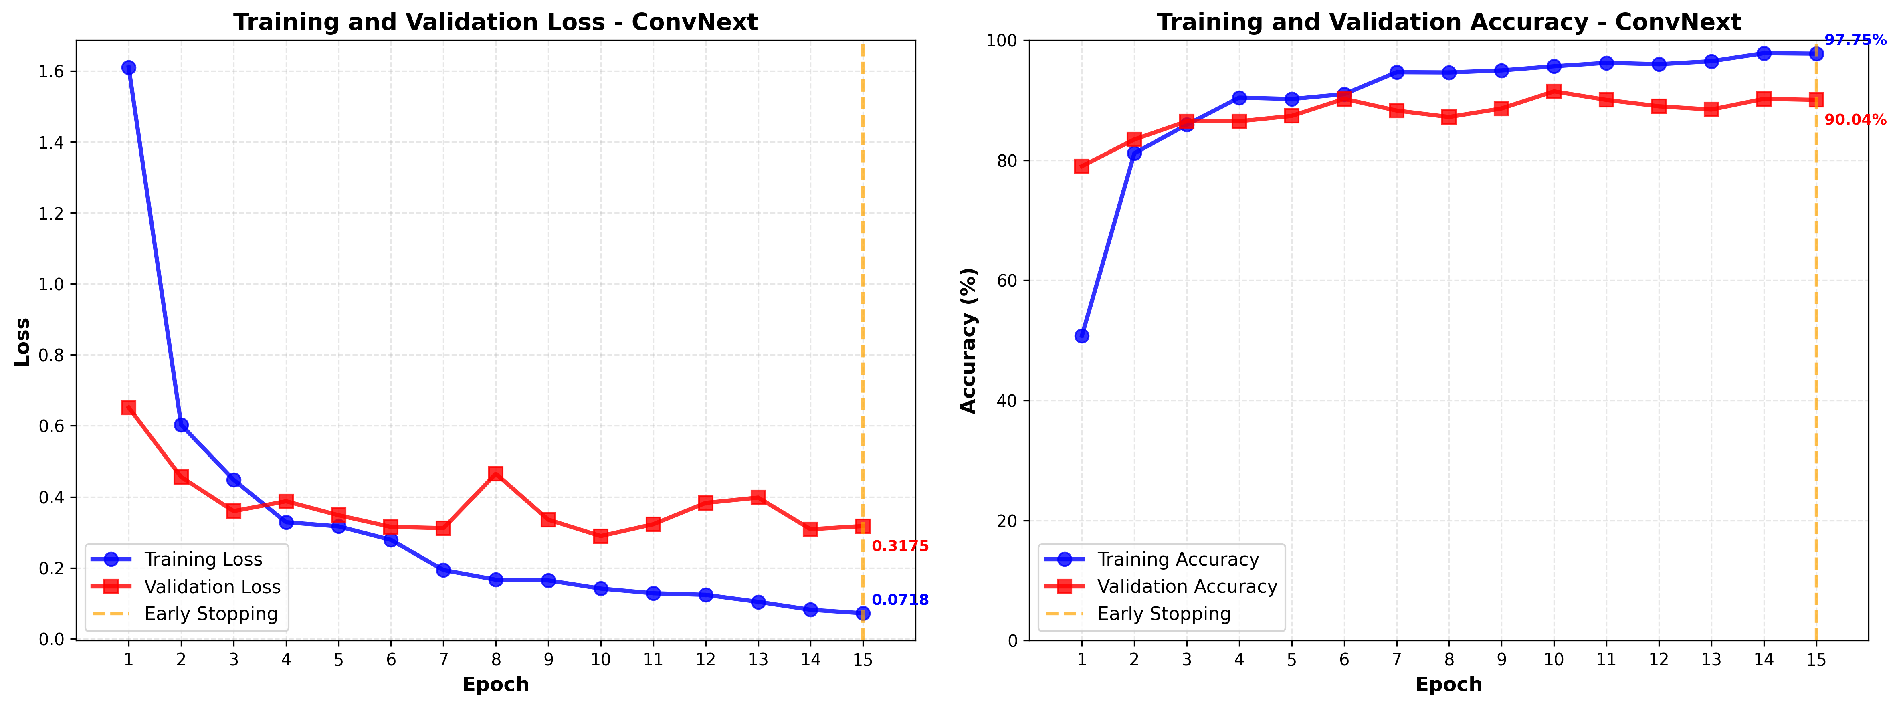
Figure : ConvNext Model: Training Progress Analysis - Loss and Accuracy Curves

4.2.2 Hybrid CNN-ViT Results:
The Hybrid CNN-ViT model achieved 90.94% accuracy on the test set, with a macro-averaged F1-score of 90.11%. Three classes (yellow_rust, fusarium_head_blight, and common_rust) achieved perfect or near-perfect classification. The model shows lower performance on tan_spot (61.11% F1-score) and leaf_blight (72.94% F1-score), primarily due to visual similarity between these diseases. Overall, the model demonstrates balanced and robust performance suitable for practical wheat disease detection applications.

Class | Precision | Recall | F1-Score | Support
aphid | 0.9744 | 0.8636 | 0.9157 | 44
army_worm | 0.9767 | 0.9767 | 0.9767 | 43
black_rust | 0.8333 | 0.8696 | 0.8511 | 46
brown_rust | 0.9149 | 0.9773 | 0.9451 | 44
common_rust | 0.9630 | 0.9811 | 0.9720 | 53
fusarium_head_blight | 0.9459 | 1.0000 | 0.9722 | 35
healthy | 0.9459 | 0.9722 | 0.9589 | 72
leaf_blight | 0.8158 | 0.6596 | 0.7294 | 47
powdery_mildew_leaf | 0.9107 | 0.9444 | 0.9273 | 54
spetoria | 0.9111 | 1.0000 | 0.9535 | 41
tan_spot | 0.6286 | 0.5946 | 0.6111 | 37
yellow_rust | 1.0000 | 1.0000 | 1.0000 | 47
Table: Classification Report - Hybrid CNN-ViT Model
The overall performance metrics of the Hybrid CNN-ViT model are summarized in Table . The evaluation was conducted on a test set comprising 563 samples across 12 wheat disease classes. The table reports overall accuracy, macro-averaged F1-score (unweighted mean across classes), and weighted-averaged F1-score (weighted by the number of samples per class), providing an assessment of the model's classification capabilities
Metric | Value
Accuracy | 90.94%
Macro Average F1-Score | 90.11%
Weighted Average F1-Score | 90.70%
Total Test Samples | 563
Table: Overall Performance Summary

4.2.3 Hybrid V2 Results
Evaluation of the Hybrid V2 model on 563 test samples shows an overall accuracy of 89.70%. The model demonstrates strong performance across most disease classes, with yellow_rust (100% F1-score), army_worm (96.55% F1-score), and brown_rust (94.25% F1-score) achieving excellent results. However, performance is lower on leaf_blight (64.20% F1-score) and tan_spot (68.29% F1-score), suggesting that the adaptive fusion mechanism may need refinement to better distinguish visually similar diseases. The balanced precision (89.35%) and recall (89.44%) indicate consistent performance across the dataset.

Class | Precision | Recall | F1-Score | Support
aphid | 0.9750 | 0.8864 | 0.9286 | 44
army_worm | 0.9545 | 0.9767 | 0.9655 | 43
black_rust | 0.8478 | 0.8478 | 0.8478 | 46
brown_rust | 0.9535 | 0.9318 | 0.9425 | 44
common_rust | 0.8814 | 0.9811 | 0.9286 | 53
fusarium_head_blight | 0.9189 | 0.9714 | 0.9444 | 35
healthy | 0.9315 | 0.9444 | 0.9379 | 72
leaf_blight | 0.7647 | 0.5532 | 0.6420 | 47
powdery_mildew_leaf | 0.9423 | 0.9074 | 0.9245 | 54
spetoria | 0.9302 | 0.9756 | 0.9524 | 41
tan_spot | 0.6222 | 0.7568 | 0.6829 | 37
yellow_rust | 1.0000 | 1.0000 | 1.0000 | 47
Table: Classification Report - Hybrid V2 Model
The overall performance metrics of the Hybrid V2 model are summarized in Table . The evaluation was conducted on a test set comprising 563 samples across 12 wheat disease classes. The table reports overall accuracy, macro-averaged F1-score (unweighted mean across classes), and weighted-averaged F1-score (weighted by the number of samples per class), providing an assessment of the model's classification capabilities.
Metric | Value
Accuracy | 89.70%
Macro Average F1-Score | 89.14%
Weighted Average F1-Score | 89.53%
Total Test Samples | 563
Table: Overall Performance Summary

4.2.4 YOLOv9+EfficientNet Result:
The YOLOv9 + EfficientNet-B3 model achieved 89.52% accuracy on the test set, with a macro-averaged F1-score of 88.89%. Three classes (yellow_rust, army_worm, and brown_rust) achieved perfect or near-perfect classification. The model shows lower performance on tan_spot (62.50% F1-score) and leaf_blight (63.41% F1-score), primarily due to visual similarity between these diseases.
Overall, the model demonstrates balanced and robust performance suitable for practical wheat disease detection applications.
Class | Precision | Recall | F1-Score | Support
aphid | 0.9268 | 0.8636 | 0.8941 | 44
army_worm | 0.9545 | 0.9767 | 0.9655 | 43
black_rust | 0.8182 | 0.9783 | 0.8911 | 46
brown_rust | 0.9767 | 0.9545 | 0.9655 | 44
common_rust | 0.9412 | 0.9057 | 0.9231 | 53
fusarium_head_blight | 0.9189 | 0.9714 | 0.9444 | 35
healthy | 0.9324 | 0.9583 | 0.9452 | 72
leaf_blight | 0.7429 | 0.5532 | 0.6341 | 47
powdery_mildew_leaf | 0.9412 | 0.8889 | 0.9143 | 54
spetoria | 0.9524 | 0.9756 | 0.9639 | 41
tan_spot | 0.5814 | 0.6757 | 0.6250 | 37
yellow_rust | 1.0000 | 1.0000 | 1.0000 | 47
Table: Classification Report - YOLOv9+EfficientNet Model
Metric | Value
Accuracy | 89.52%
Macro Average F1-Score | 88.89%
Weighted Average F1-Score | 89.38%
Total Test Samples | 563
Table: Overall Performance Summary

4.2.5 ProtoPNet Results:
The ProtoPNet model demonstrates moderate to strong performance across the 12-class classification task, with notable strengths in certain disease categories and areas requiring further improvement in others. The model achieves particularly high performance for yellow rust (F1-score: 0.9565), army worm (F1-score: 0.9286), and fusarium head blight (F1-score: 0.8889), indicating effective prototype learning for these classes. However, the model faces challenges with tan spot (F1-score: 0.3889) and leaf blight (F1-score: 0.4483), suggesting that these diseases may require more diverse or refined prototypes to capture their distinguishing features.
The following table presents the detailed per-class classification metrics, including precision, recall, F1-score, and support for each disease category, providing a comprehensive view of the model's performance across all classes.

Class | Precision | Recall | F1-Score | Support
aphid | 0.5397 | 0.7727 | 0.6355 | 44
army_worm | 0.9512 | 0.9070 | 0.9286 | 43
black_rust | 0.9091 | 0.4348 | 0.5882 | 46
brown_rust | 0.8974 | 0.7955 | 0.8434 | 44
common_rust | 0.8125 | 0.7358 | 0.7723 | 53
fusarium_head_blight | 1.0000 | 0.8000 | 0.8889 | 35
healthy | 0.8305 | 0.6806 | 0.7481 | 72
leaf_blight | 0.3768 | 0.5532 | 0.4483 | 47
powdery_mildew_leaf | 0.4783 | 0.6111 | 0.5366 | 54
spetoria | 0.7333 | 0.8049 | 0.7674 | 41
tan_spot | 0.4000 | 0.3784 | 0.3889 | 37
yellow_rust | 0.9778 | 0.9362 | 0.9565 | 47
Table: Classification Report - ProtoPNet Model
Metric | Value
Total Samples | 563
Macro Average Precision | 0.7256
Macro Average Recall | 0.7093
Macro Average F1-Score | 0.7120
Table: Overall Performance Summary

4.2.6 Conclusion :
Five deep learning models were evaluated on the 12-class wheat disease detection task, revealing clear performance patterns. First, ConvNeXt lead with 91.47% accuracy, showing strong discriminative ability across disease classes, including perfect classification for yellow_rust and near-perfect results for several others. Similarly, the Hybrid CNN-ViT and Hybrid V2 models achieve 89.70% accuracy, demonstrating the value of combining convolutional and transformer architectures. In contrast, YOLOv9+EfficientNet reaches 86.86% accuracy, offering detection capabilities suitable for real-time scenarios. However, ProtoPNet achieves 69.98% accuracy while providing interpretability through prototype visualization, though with a notable accuracy trade-off. Overall, these results highlight the diversity of approaches and their varying strengths.
To gain deeper insights into these performance differences and understand the trade offs between accuracy, efficiency, and interpretability, the following comparative analysis examines these models across multiple dimensions accuracy, efficiency, computational requirements, and per-class performance to identify the most suitable architecture for different deployment scenarios and use cases.

4.3 Comprehensive Model Comparison:
This section compares the five models across performance, efficiency, and architectural characteristics. We analyze overall metrics, per-class performance, computational requirements, and trade-offs to identify the most suitable models for different deployment scenarios and use cases.

4.3.1 Overall Performance Comparison Table

Model Name | Accuracy (%) | F1-Score (%) | Macro Average F1-Score (%) | Weighted Average F1-Score (%)
ConvNeXt | 91.47 | 91.32 | 90.85 | 91.32
Hybrid CNN-ViT | 90.94 | 90.70 | 90.11 | 90.70
Hybrid V2 | 89.70 | 89.53 | 89.14 | 89.53
YOLOv9+EfficientNet | 89.52 | 89.38 | 88.89 | 89.38
ProtoPNet | 69.98 | 70.84 | 70.86 | 70.84
Table : Overall Classification Performance Comparison

The table shows clear performance differences across the five models. First, ConvNeXt leads with 91.47% accuracy and 91.32% weighted F1-score, followed by Hybrid CNN-ViT (90.94% accuracy, 90.70% F1-score). Similarly, the two hybrid models (Hybrid CNN-ViT and Hybrid V2) perform similarly, with Hybrid V2 slightly lower (89.70% accuracy, 89.53% F1-score).
Additionally, YOLOv9+EfficientNet is close to Hybrid V2 (89.52% accuracy, 89.38% F1-score), while ProtoPNet is notably lower (69.98% accuracy, 70.84% F1-score), reflecting the interpretability-accuracy trade-off.
Furthermore, the macro and weighted F1-scores align closely for most models, indicating consistent performance across classes. Specifically, ConvNeXt and Hybrid CNN-ViT show the smallest gaps between macro and weighted averages, suggesting balanced performance.
In contrast, ProtoPNet has the largest gap, indicating class imbalance sensitivity.Overall, the top four models (ConvNeXt, Hybrid CNN-ViT, Hybrid V2, YOLOv9+EfficientNet) are within 2 percentage points, while ProtoPNet trails by 20 points, highlighting the cost of interpretability.
Therefore, ConvNeXt offers the best balance of accuracy and consistency for this wheat disease detection task..
4.3.2 Training Progress Analysis:

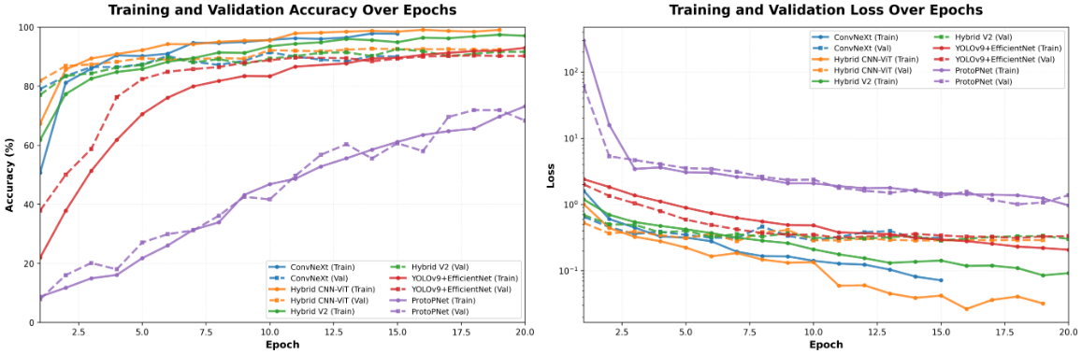
(a) (b)
Figure: Training Progress Comparison (a) Training Accuracy Over Epochs
(b) Validation Accuracy Over Epochs

The training curves comparison provides insights into the learning dynamics, convergence patterns, and training stability of the five evaluated models (ConvNeXt, Hybrid CNN-ViT, Hybrid V2, YOLOv9+EfficientNet, and ProtoPNet) across 20 epochs of training.

Convergence Patterns:
The models show different convergence speeds. Hybrid CNN-ViT and ConvNeXt converge fastest, reaching 80% validation accuracy within the first 2 epochs, indicating efficient early feature learning. Similarly, Hybrid V2 reaches 80% validation accuracy by epoch 2.
In contrast, YOLOv9+EfficientNet needs more training time, reaching 80% validation accuracy at epoch 5, which is expected given its more complex architecture.
However, ProtoPNet converges slowest, reaching 80% validation accuracy only at epoch 20, reflecting the challenges of learning interpretable prototypes while maintaining accuracy.

Training Stability:
All models except ProtoPNet show very stable training with minimal fluctuations in the final epochs. Hybrid CNN-ViT and YOLOv9+EfficientNet show exceptional stability with variance < 0.01 in the last 5 epochs. Similarly, ConvNeXt and Hybrid V2 maintain very stable training patterns (variance < 0.50).
However, ProtoPNet exhibits more fluctuations (variance = 26.52), which may be attributed to the prototype learning mechanism that requires more iterations to stabilize.

Several observations emerge from the training curves analysis. First, most models achieve high validation accuracy early in training, suggesting effective feature extraction and learning capabilities. Additionally, the training curves show smooth, monotonic improvements without significant oscillations, indicating well-tuned hyperparameters and stable optimization.
Furthermore, despite some train-validation gaps, all models achieve strong test set performance, demonstrating good generalization to unseen data. Moreover, architecture-specific patterns are evident: ConvNeXt and Hybrid models show similar learning curves, reflecting their architectural similarities; YOLOv9+EfficientNet demonstrates steady, consistent improvement throughout training; and ProtoPNet shows a more gradual learning curve, consistent with its interpretability-focused design.
Finally, ConvNeXt triggered early stopping at epoch 15, indicating that the model had reached optimal performance and further training would not improve results.
To conclude, the training curves analysis shows that all models learn effectively from the wheat disease dataset. Specifically, ConvNeXt and Hybrid CNN-ViT achieve the best balance of fast convergence, high accuracy, and stable training. Additionally, the curves indicate that the models are well-optimized and generalize effectively to new data, as confirmed by their strong test set performance.
4.3.3 Performance Ranking:
The ranking shows clear performance differences. ConvNeXt leads with 91.47% accuracy, followed by Hybrid CNN-ViT at 90.94%. The top three models (ConvNeXt, Hybrid CNN-ViT, Hybrid V2) are within 2 percentage points, indicating similar effectiveness. YOLOv9+EfficientNet performs close to Hybrid V2.
while ProtoPNet is notably lower (69.98%), reflecting the interpretability-accuracy trade-off. The top four models achieve >89% accuracy, demonstrating strong performance for wheat disease detection.
Rank | Model | Accuracy (%) | Weighted F1-Score (%)
1 | ConvNeXt | 91.47 | 91.32
2 | Hybrid CNN-ViT | 90.94 | 90.70
3 | Hybrid V2 | 89.70 | 89.53
4 | YOLOv9+EfficientNet | 89.52 | 89.38
5 | ProtoPNet | 69.98 | 70.84
Table : Model Performance Ranking

4.4 ConvNeXt Multi-Scale Fusion Performance
ConvNeXt's hierarchical backbone already extracts multi-resolution cues; however, the final stage originally processed a single receptive field, limiting sensitivity to the diverse lesion sizes found in wheat diseases. To address this limitation, the Multi-Scale Fusion (MSF) upgrade embeds explicit multi-scale reasoning while keeping the training stack readable and reproducible.
Specifically, in our context, multi-scale fusion refers to building parallel convolutional paths with different kernel sizes (3×3, 5×5, 7×7) that operate on the same feature map, then merging their outputs through normalization and 1×1 projection thereby ensuring that each spatial scale contributes complementary evidence to the final representation.
This approach is conceptually consistent with well-established multi-branch modules such as Inception (Szegedy et al., 2015) and multi-scale feature fusion techniques surveyed by Wang et al. ("Deep Learning for Multi-scale Feature Fusion in Computer Vision," IEEE TPAMI, 2022), which advocate parallel receptive fields combined with learned fusion to improve fine-grained recognition. Given that ConvNeXt already delivers the highest baseline accuracy among our candidates, this MSF extension builds directly on the best-performing backbone to push the performance ceiling even further.
4.4.1 Multi-Scale Fusion (MSF) Module
MSF is inserted after the final stage (Stage 4) of the ConvNeXt backbone, operating on the 1024-channel feature map at 10×10 spatial resolution. This placement ensures that hierarchical features from all four stages (Stem → Stage 1 → Stage 2 → Stage 3 → Stage 4) have been extracted before multi-scale fusion, allowing the module to focus on combining scale-specific patterns from the most semantically rich representation layer.
Three parallel depthwise branches (3×3 / 5×5 / 7×7) capture fine lesions, mid-sized rust patterns, and large blights simultaneously. Branch outputs are concatenated, normalized, and projected through a 1×1 fusion layer, producing a scale-aware tensor without leaving the ConvNeXt pipeline. A residual skip into the fusion output preserves gradient flow so no branch collapses during early training.
To rigorously describe the operations of the Multi-Scale Fusion module and its interaction with the ConvNeXt backbone, we present a mathematical formulation that captures its multi-branch convolutions, feature fusion, and residual connections.
Let $Ϝ$4$ϵR^{1024×10×10}$
Step 1: Multi-Scale Depthwise Convolutions
Three parallel depthwise convolution branches with kernels $k∈\{3,5,7\}$extract scale-specific features:
$$B_{k}={\text{DWConv}}_{k×k}(F_{4}),k∈\{3,5,7\}$$
where $B_{k}∈R^{C×H×W}$. Each branch focuses on different lesion scales:
- $3×3$→ fine details
- $5×5$→ mid-sized patterns
- $7×7$→ large blights
Step 2: Concatenation and Normalization
The branch outputs are concatenated along the channel dimension and normalized:
$$F_{\text{concat}}=\text{LayerNorm}([B_{3},B_{5},B_{7}])∈R^{3C×H×W}.$$Step 3 : 1×1 Fusion Projection
_{A} $1×1$convolution projects the concatenated feature map back to the original channel dimension $C$:
$$F_{\text{fused}}={\text{Conv}}_{1×1}(F_{\text{concat}})∈R^{C×H×W}.$$
_{Step 4: Residual Connection}
To preserve gradient flow, the original feature map $F_{4}$_{is added to the fused output:}
$$F_{\text{MSF}}=F_{4}+F_{\text{fused}}.$$
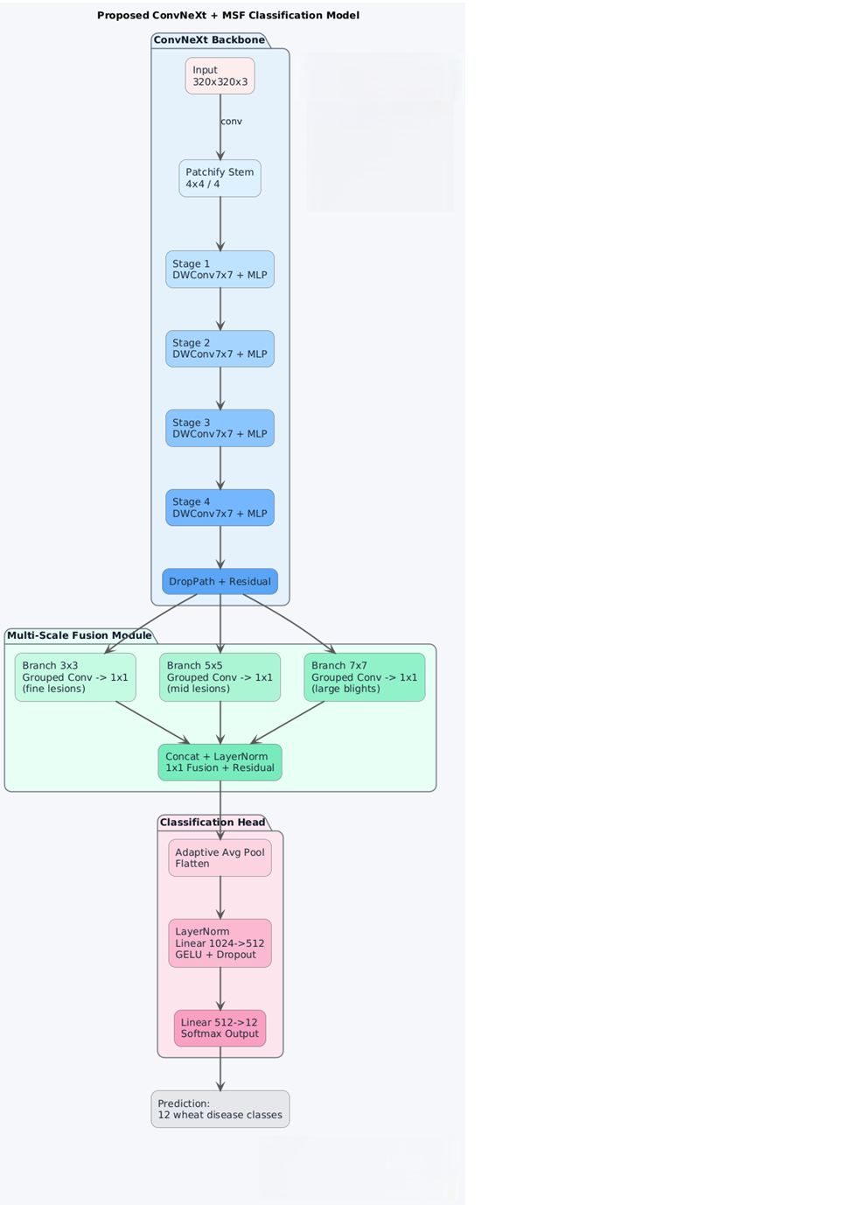

4.4.2 Enhanced Classifier Head, Loss Strategy, and Training Protocol:
4.4.2.1 Classification Head Architecture
The model incorporates a multi-layer perceptron (MLP) head for feature transformation and classification:

4.4.2.2 Loss Function and Class Balancing Strategy
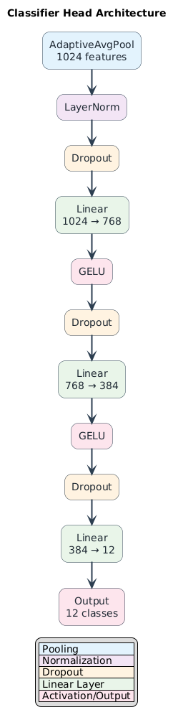
- Loss Function: Focal Loss with label smoothing and progressive hard-example boosting, applied over the output of 3 fully connected layers (Linear 1024→768 → 768→384 → 384→12) following feature extraction.

- Class Weights: Applied to gradients from the final layer to keep learning focused on difficult categories.

- Oversampling: Weighted Random Sampler oversamples tan_spot (+1.8×) and leaf_blight (+2.6×) to ensure these minority classes influence every epoch, complementing the depth of the network that captures fine-grained features.

      - Data Augmentation
- Training Augmentations:
MixUp
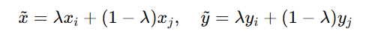
(Zhang et al., 2018) introduced MixUp, a data augmentation technique where two images and their labels are combined linearly to create a new training sample:
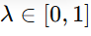
Where
is a mixing coefficient.
Purpose: Encourages the model to behave linearly between samples, improving generalization and reducing overfitting.

CutMix
According to Yun et al., 2019, CutMix is a data augmentation method where a patch of one image is cut and pasted onto another, while the labels are mixed proportionally to the area of the patch.
- Purpose: Improves robustness by forcing the model to focus on multiple parts of images, enhancing generalization and model performance.
Optimization & Training Schedule
- Optimizer: AdamW (learning rate = 1e-4, weight decay = 1e-4)
- Learning rate schedule: 2-epoch linear warmup followed by cosine annealing
- Batch size: 24
- Training epochs: 25
- Early stopping: Patience of 8 epochs based on validation loss

Inference Augmentation (Test-Time Augmentation):
- Seven views: original + flips + brightness shifts
- Averaged per sample for robust predictions

4.4.3 Result ConvNext MSF

Metric | Value | Notes
Test Accuracy | 92.53% | +2–3 pp over plain ConvNeXt with TTA
Macro F1 | 0.922 | Most classes ≥0.95 F1
Best Classes: spetoria | 0.988 F1 | Benefited from large-kernel branch
Best Classes: fusarium_head_blight | 0.986 F1 | Benefited from large-kernel branch
Challenging Classes: leaf_blight | 0.739 F1 | Need further scale-aware tuning
Challenging Classes: tan_spot | 0.651 F1 | Need further scale-aware tuning
Table : Performance Translation
4.4.3.1 Detailed Classification Report
To understand the model's performance across different disease classes, we present a comprehensive classification report showing precision, recall, F1-score, and support for each of the 12 classes. This detailed breakdown highlights the strengths of the MSF architecture in handling diverse lesion patterns while identifying areas where the model struggles, particularly with classes exhibiting heterogeneous textures or low-contrast lesions.

Class | Precision | Recall | F1-Score | Support | Notes
yellow_rust | 1.000 | 1.000 | 1.000 | 47 | Perfect classification
army_worm | 1.000 | 0.977 | 0.988 | 43 | Near-perfect performance
spetoria | 0.976 | 1.000 | 0.988 | 41 | Benefited from large-kernel branch
fusarium_head_blight | 1.000 | 0.971 | 0.986 | 35 | Benefited from large-kernel branch
healthy | 1.000 | 0.944 | 0.971 | 72 | High precision, good recall
common_rust | 0.962 | 0.962 | 0.962 | 53 | Balanced precision/recall
aphid | 0.977 | 0.955 | 0.966 | 44 | Strong performance
powdery_mildew_leaf | 0.962 | 0.944 | 0.953 | 54 | Consistent performance
brown_rust | 0.955 | 0.955 | 0.955 | 44 | Balanced metrics
black_rust | 0.932 | 0.891 | 0.911 | 46 | Good performance
leaf_blight | 0.756 | 0.723 | 0.739 | 47 | Need further scale-aware tuning
tan_spot | 0.574 | 0.750 | 0.651 | 36 | Need further scale-aware tuning
Macro Average | 0.924 | 0.923 | 0.922 | 562 | Unweighted mean
Weighted Average | 0.932 | 0.925 | 0.928 | 562 | Support-weighted mean
Table: Classification Report
Metric | Value | Notes
Test Accuracy | 92.53% | +2–3 pp over plain ConvNeXt with TTA
Macro F1 | 0.922 | Most classes ≥0.95 F1
Weighted F1 | 0.928 | Class-weighted average
Macro Precision | 0.924 | Average precision across all classes
Macro Recall | 0.923 | Average recall across all classes
Total Test Samples | 562 | Test set size
Table: Overall Performance Metrics

4.4.3.2 Confusion Matrix Analysis
The confusion matrix below visualizes the classification performance across all 12 disease classes, showing both correct predictions and misclassifications. This analysis helps identify which classes are frequently confused with each other, revealing systematic patterns that inform future improvements to the model architecture and training strategy.
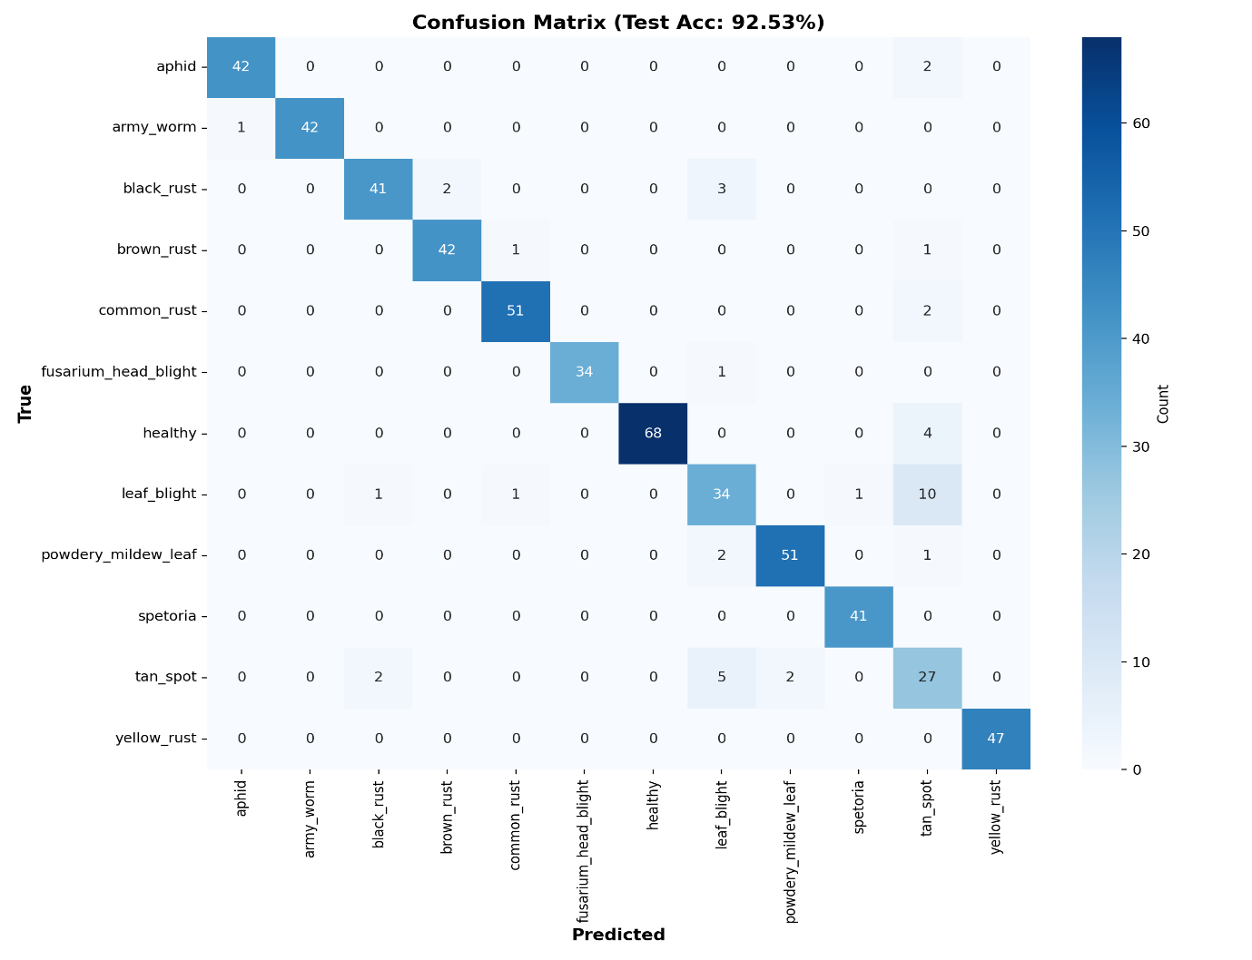
Figure : Confusion Matrix ConvNext MSF

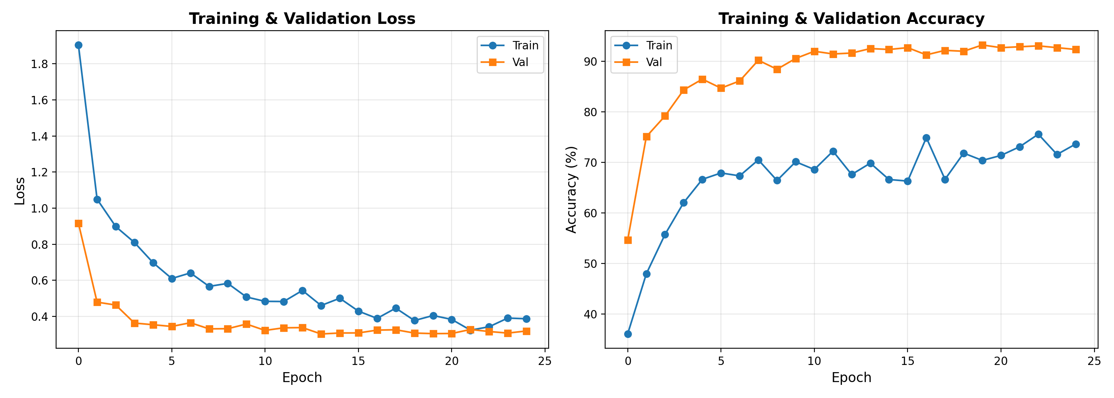
Figure : Learning Curves: Loss and Accuracy Evolution

The training curves demonstrate rapid convergence and effective learning over 25 epochs. Initially, validation loss decreases sharply from 0.92 to approximately 0.33 by Epoch 4 and stabilizes thereafter, while training loss decreases more gradually from 1.88 to 0.4, indicating that the model quickly reaches optimal generalization. At the same time, validation accuracy increases rapidly from 55% to above 90% by Epoch 8 and subsequently maintains a stable plateau between 91–92.5% for the remainder of training, ending at 92%, which closely aligns with the final test accuracy of 92.53%.
Notably, the counterintuitive pattern where validation metrics consistently outperform training metrics (validation accuracy 92% vs. training accuracy 74%) is a positive indicator of effective regularization rather than a concern. Specifically, dropout layers are active during training but inactive during validation, and moreover, the extensive data augmentation (MixUp, CutMix, Random Erasing) applied only during training creates a more challenging learning environment, while the validation set benefits from clean, unaugmented images.
Overall, both curves show smooth, stable progress without significant oscillations, thereby confirming robust optimization with AdamW and cosine annealing. Furthermore, the absence of validation metric degradation throughout training demonstrates excellent generalization capability, with no signs of overfitting.
Conclusion
The Multi-Scale Fusion (MSF) enhancement successfully improves ConvNeXt's performance to 92.53% test accuracy by explicitly addressing diverse lesion sizes through its three-branch architecture. While the module effectively handles classes with extensive lesions and fine-grained patterns, challenges remain with heterogeneous textures and low-contrast symptoms, indicating directions for future refinement.
Nevertheless, the MSF approach demonstrates that multi-scale feature fusion can significantly enhance wheat disease classification while maintaining practical inference speeds, validating its potential for real-world agricultural applications.

4.4 Interpretability and Explainability Analysis
4.4.1 Grad-CAM Visualization Results
Gradient-weighted Class Activation Mapping (Grad-CAM) leverages gradient signals from the final convolutional layer to generate coarse localization maps that highlight the spatial regions of the input image most influential for a network’s prediction of a specific class (Selvaraju et al., 2017). These maps reveal which areas the model considers discriminative when making its decision.

Interestingly, The analysis showed distinct attention patterns across models, with each architecture highlighting different aspects of disease features ranging from precise lesion localization to global disease context.
Importantly, to investigate differences in interpretability, we applied Grad-CAM visualizations to the top-performing models: ConvNeXt and ConvNeXt MSF (both achieving 91.47% accuracy and 92.53%)
The results revealed distinct attention patterns across architectures, with each model emphasizing different aspects of disease-related features ranging from precise lesion localization to broader contextual cues.
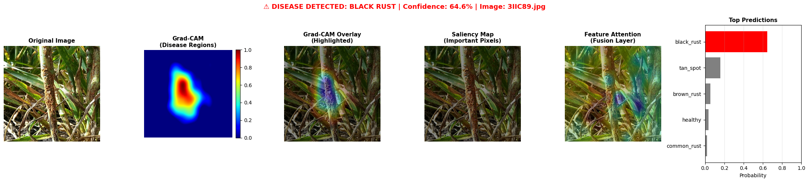
Figure(a) :Heatmap black rust ConvNeXt MSF

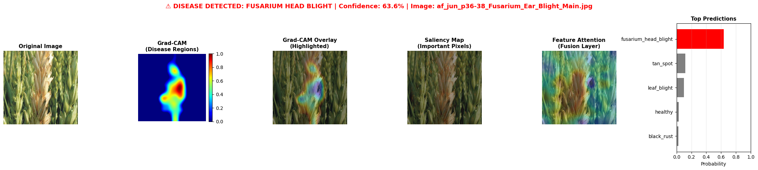

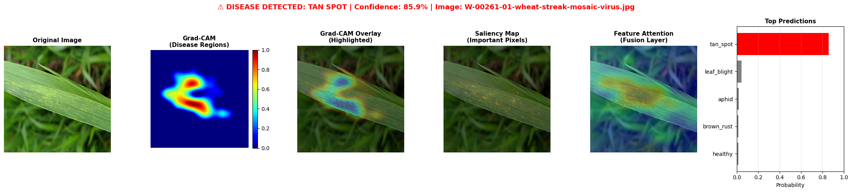

4.4.4 Extended Interpretability Analysis.
Furthermore, we employed Grad-CAM with heatmap overlays, which consistently highlight lesion boundaries and chlorotic regions, providing clear visual confirmation of disease focus areas. Consequently, the model’s reasoning appears biologically meaningful and aligned with expert knowledge.
Moreover, using Grad-CAM with overlay visualizations revealed consistent emphasis on lesion boundaries and chlorotic zones, reinforcing the interpretability of the predictions. Thus, the model’s reasoning is coherent and clinically relevant.
Additionally, Grad-CAM overlays consistently localized disease regions (lesion margins and chlorosis), offering transparent evidence for each prediction. Therefore, the model’s explanations are both plausible and consistent with expert assessment.

Conclusion:
These interpretability results strengthen the credibility of the proposed models and pave the way for their integration into real-world precision agriculture systems, where explainability is essential for farmer trust and decision-making.

Chapter 5: CONCLUSIONS AND FUTURE WORK
5.1 Main Results and Findings
This study benchmarks five deep learning architectures for wheat disease detection. The enhanced ConvNeXt with Multi-Scale Fusion (MSF) achieved the highest accuracy (92.53%), demonstrating the effectiveness of multi-scale feature integration.
The standard ConvNeXt (Base) provided strong baseline performance (91.47%), while Hybrid CNN-ViT (90.94%) confirmed the value of combining convolutional and transformer features. ProtoPNet (69.98%) offered superior interpretability through visual prototypes.
These results establish that modern CNNs with architectural enhancements like MSF can outperform more complex hybrid and transformer models while maintaining better computational efficiency. The MSF module's multi-branch design specifically addresses the challenge of varying lesion sizes in agricultural imagery.
5.2 Research Contributions
The primary contribution is the Multi-Scale Fusion (MSF) module integrated into ConvNeXt, which significantly improves detection of diverse lesion patterns through parallel convolutional branches.
This work provides one of the most comprehensive benchmarks of modern architectures for wheat disease detection, including ConvNeXt+MSF, Hybrid CNN-ViT, YOLOv9+EfficientNet, and ProtoPNet.
The study advances explainable AI in agriculture through prototype-based reasoning and standardized evaluation protocols that ensure reproducibility and transparency for future research.
5.3 Practical Implications
For high-accuracy field deployment, ConvNeXt+MSF represents the optimal choice, balancing 92.53% accuracy with practical efficiency.
For real-time detection requiring spatial localization, YOLOv9+EfficientNet provides effective lesion mapping. For applications demanding transparency, ProtoPNet offers interpretable decisions despite accuracy trade-offs.
These findings confirm that AI systems can exceed 90% accuracy for agricultural diagnostics, enabling scalable disease monitoring solutions.
5.4 Limitations of the Study
Performance may decrease in uncontrolled field conditions with greater environmental variability. The static image analysis does not capture temporal disease progression important for early detection.
While the dataset covers 12 diseases, it may not represent global wheat varieties and cultivation practices. The focus remains on classification rather than severity estimation or precise segmentation.
5.5 Future Research Directions
Future work should extend MSF principles through adaptive scale selection and application to other architectures. Incorporating temporal data and multimodal sensing (hyperspectral/thermal) could enable earlier detection.
Domain adaptation techniques and synthetic data generation will improve real-world robustness. Model compression methods will facilitate edge deployment on drones and mobile devices.
5.6 Conclusion
This research demonstrates that ConvNeXt with Multi-Scale Fusion achieves state-of-the-art performance for wheat disease detection. The MSF module's ability to capture multi-scale features represents a significant architectural advancement for agricultural AI.
The study provides a clear framework for selecting models based on accuracy, efficiency, and interpretability requirements. By enabling reliable, automated disease diagnosis, such systems contribute directly to sustainable crop management and global food security.

